**Maven V3.8.6**

**Sonarqube V9.6.1**

**To start the sonarqube server go to C:\SonarQube\sonarqube-9.6.1.59531\bin\windows-x86-64 dbl click on StartSonar.bat.**

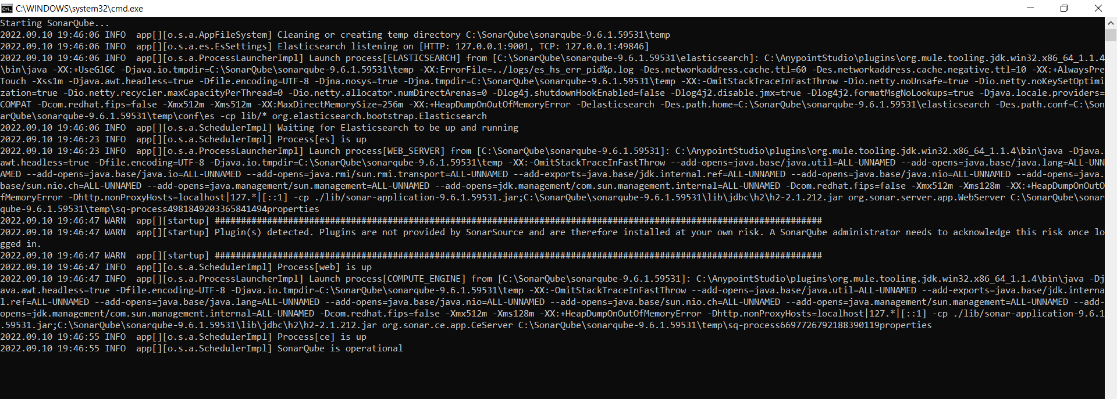

**To Stop**



**Press ctrl+c to stop the sonarqube server**

* **What is Maven?**

Maven is a tool used for compiling,testing n deploying the application easily.Maven follows project object model where it mentions all the application dependencies in one file called pom.xml.it is the main file which is used to refer the third-party-packages,dependencies in our applications.

As a developer maven will be used to copile,build,test n deploy the app with its dependencies in a server.

As a devops engineer,maven used for managing dependencies,build,unit test n deploy the code .

Developer(writes the code n pushes to SCM)->SCM Tool(github)->will call maven for (fetching n downloading dependencies then build then test n then deploy the app.

**Maven Setup:**

Maven can be downloaded from [here](https://maven.apache.org/download.cgi) . Maven requires JAVA JDK Installed on your system so JAVA can be downloaded from [here](https://adoptium.net/en-GB/temurin/releases/?version=11) . Set environment variables for both in system settings

**Maven Coordinates:**

Maven coordinates is a combination of Group Id,Artifact Id, Version,package declared for an app while creating the app.

Group Id: It is unique amongest organization or a project. n can be same for two or more apps created under same org n it can be reverse url of website like actual web url is [google.com](http://www.google.com) so Group Id can be com.google etc or (wm.com) will be com.wm

Artifact Id: it is like a name that the project is known by.It should be unique for each n every application.

Version: groupid n artifactid defines single project but what if the same project has so many version like 1.0,1.1,1.9,2.0….. for that version is defined to dentify particular projets’s particular version.

Packaging is a complete name by which a project artifact will be generated as .jar file or .war fie to get deployed. For eg:

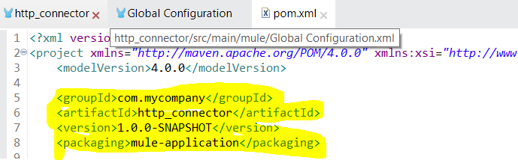





**Maven lifecycle:**

Each of these build lifecycles is defined by a different list of build phases, wherein a build phase represents a stage in the lifecycle.

For example, the default lifecycle comprises of the following phases (for a complete list of the lifecycle phases, refer to the [Lifecycle Reference](https://maven.apache.org/guides/introduction/introduction-to-the-lifecycle.html#Lifecycle_Reference)):

* validate - validate the project is correct and all necessary information is available
* compile - compile the source code of the project
* test - test the compiled source code using a suitable unit testing framework. These tests should not require the code be packaged or deployed
* package - take the compiled code and package it in its distributable format, such as a JAR.
* verify - run any checks on results of integration tests to ensure quality criteria are met
* install - install the package into the local repository, for use as a dependency in other projects locally
* deploy - done in the build environment, copies the final package to the remote repository for sharing with other developers and projects.

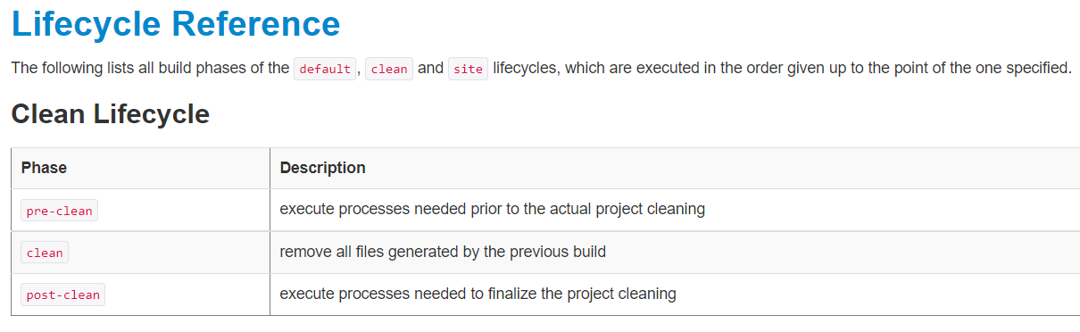

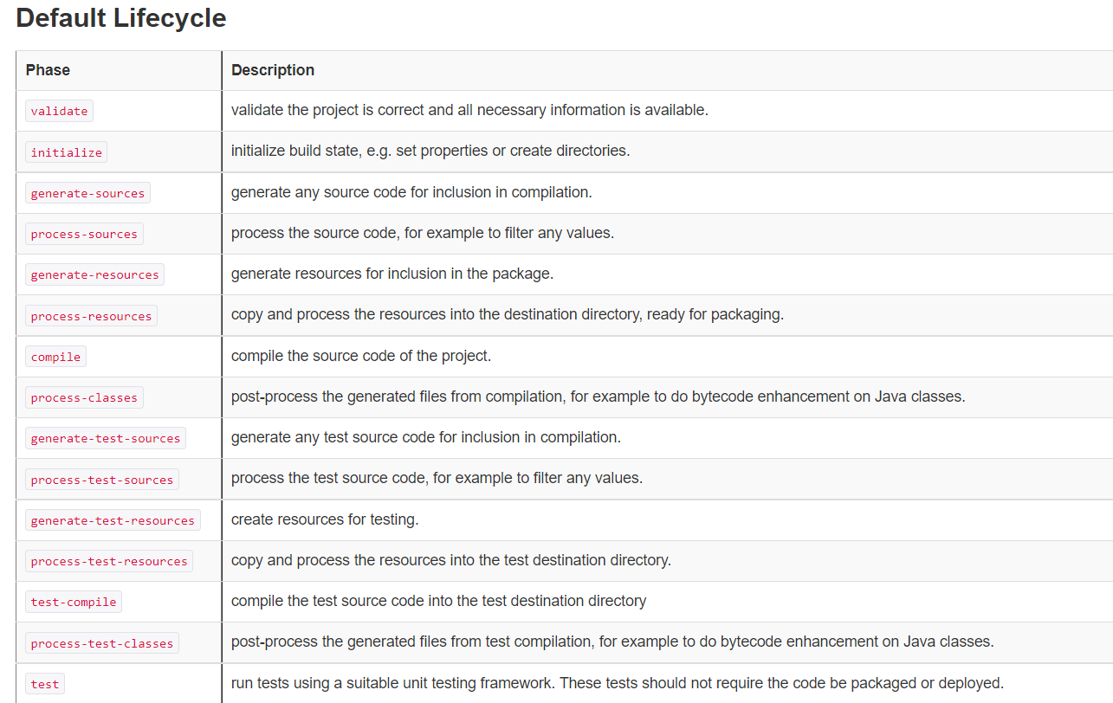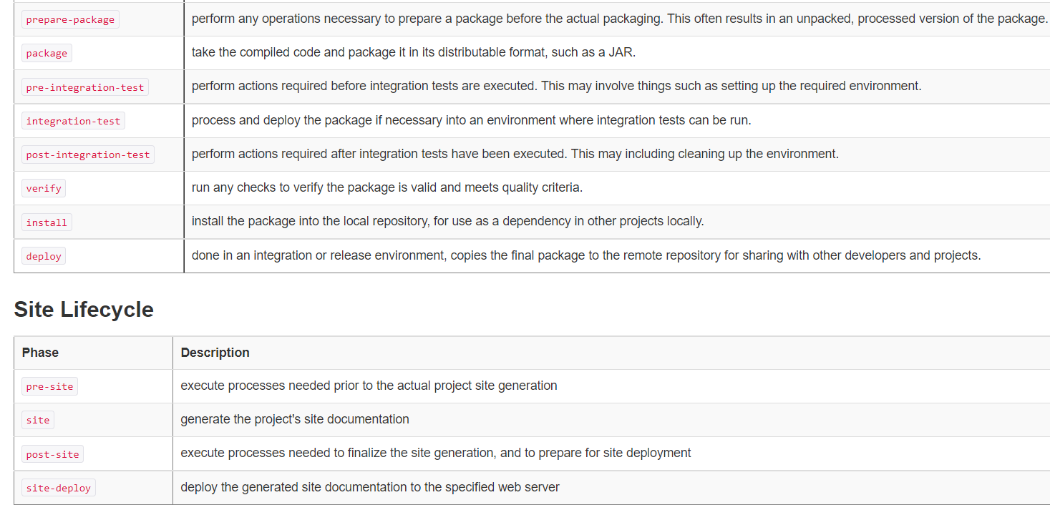

If we do mvn deploy then all steps of default lifecycle starting from validate to deploy will get performed automatically.n if we do mvn test then all steps of default lifecycle starting from validate to test will get performed automatically.

Compile is the phase where mvn creates target directory

Compile-tests is the phase where src code +test cases files are compiled n generates .class file

To create a jar file we need atleast mvn package command

To create a jar file n move it into local .m2 directory we need mvn install command

**POM.xml**

Pom.xml is the main file which contains info abt project n configurations used by maven to build the project.it contains default values for most of the project.eg: build directory =target folder,src directory=src/main/mule,src test directory=src/test/munit

Pom.xml can involve configurations like project dependencies,plugins,goals,build profiles,project version,desc,developers,mailing list etc.

Maven Repositories:-

There are 2 types of repositories 1) Local Repo 2) Remote Repo(Maven central Repo)

Local repo :

It is .m2 folder normally gets created on first build usually under c:/users/<<userprofile>>/.m2. for eg: C:\Users\sdubalgunde\.m2

When user runs an app all required n mentioned dependencies in pom.xml are downloaded from internet n get stored into local repo.so that the same dependencies are used by any other app or in next run of same app the dependencies will be get from local repo n not the over the internet again n again

Remote Repo(Maven central Repo):

The [Maven Central Repo Link](https://repo1.maven.org/maven2/) is a remote repo from where all dependencies mentioned in pom.xml file of the app will get downloaded from.

When user runs an app

Remote Repo

(Maven Central Repo)

User1 Local Repo<

User2 local repo<

**Internet**

User3 local repo<

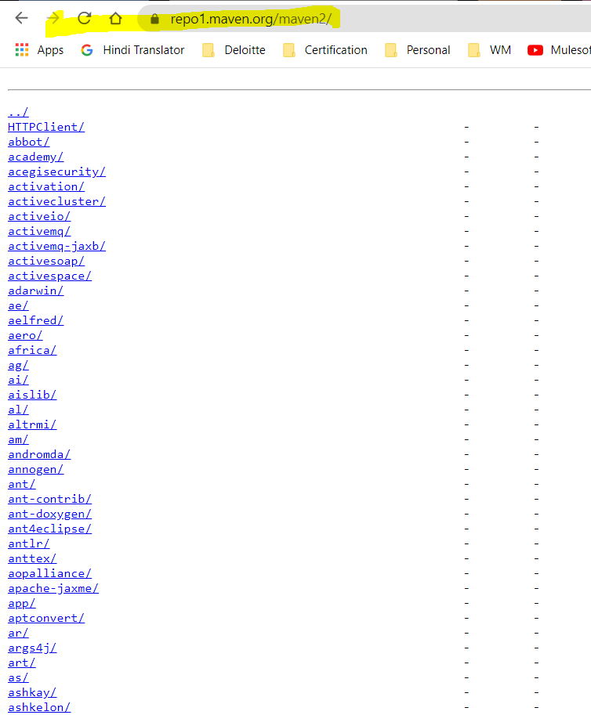

In case if we want to fetch the dependency for junit 3.82 version n the same dependency version is mentioned in pom.xml which is not there in maven central repo also then we will get an error for pom.xml .

**Settings.xml:**

It ia file which contains global level configuration used for aven.Like pom.xml in an app is a config file for that app only settings.xml is a config file for all the apps where we can specify common configs that can be used by each n every app.

Settings.xml file can be found in:

1. C:\apache-maven-3.8.6\conf

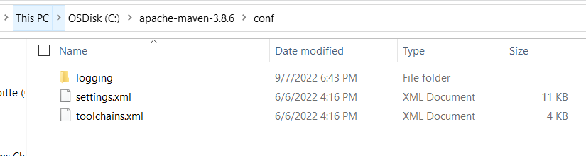

1. C:\Users\sdubalgunde\.m2

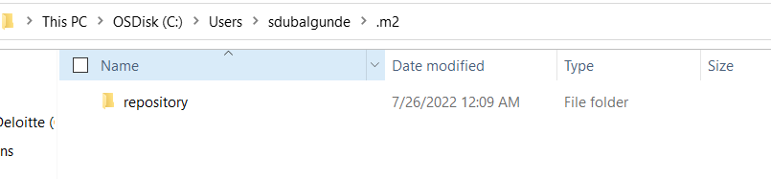

We can create settings.xml here also.

* What is Sonarqube?

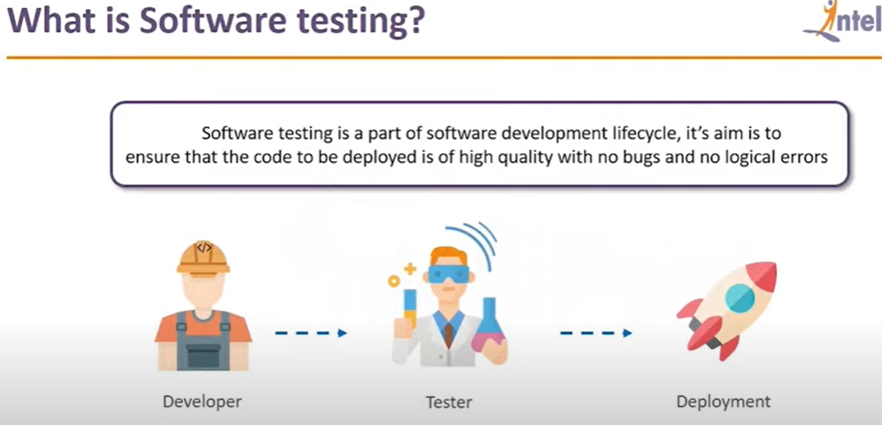

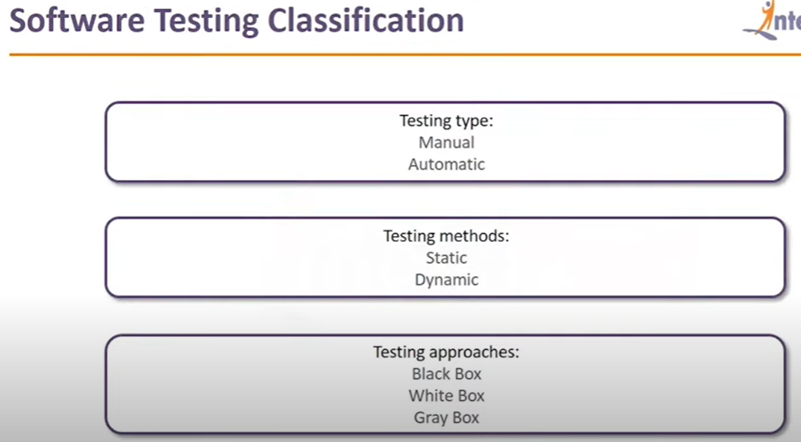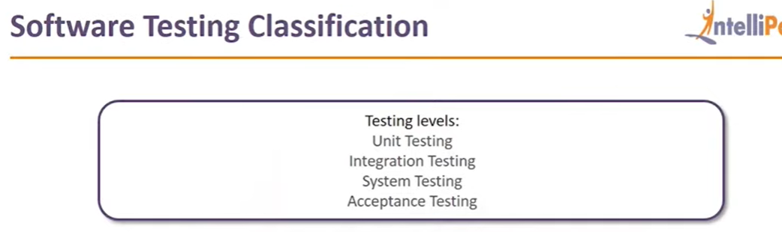

**Code Quality Analysis:**

Code that the developer has written needs to be checked on below parameters for making assure that code has quality:

* Code is bug free? No error
* Code is secure? code has no secure pwds ,confidential info which are visible
* Duplications avoided? No duplicate set of code written
* Tested properly?Test coverage is 100%?
* Complex Code? Code can be simplified ?
* Easy to integrate with other codes?

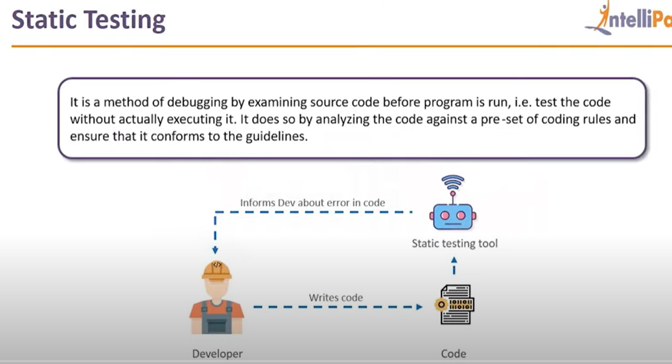

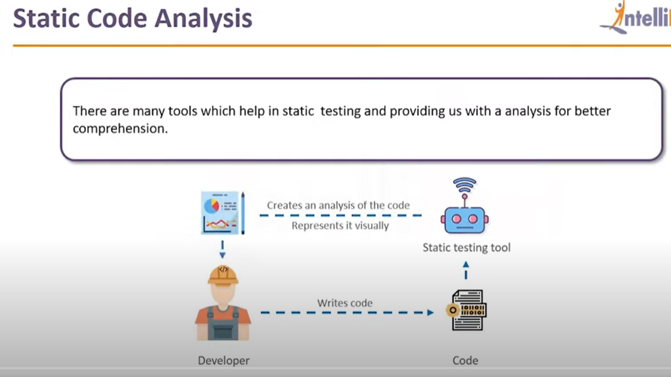

Sonarqube is an example of tools that are used for static code analysis(debugging the code before execution.

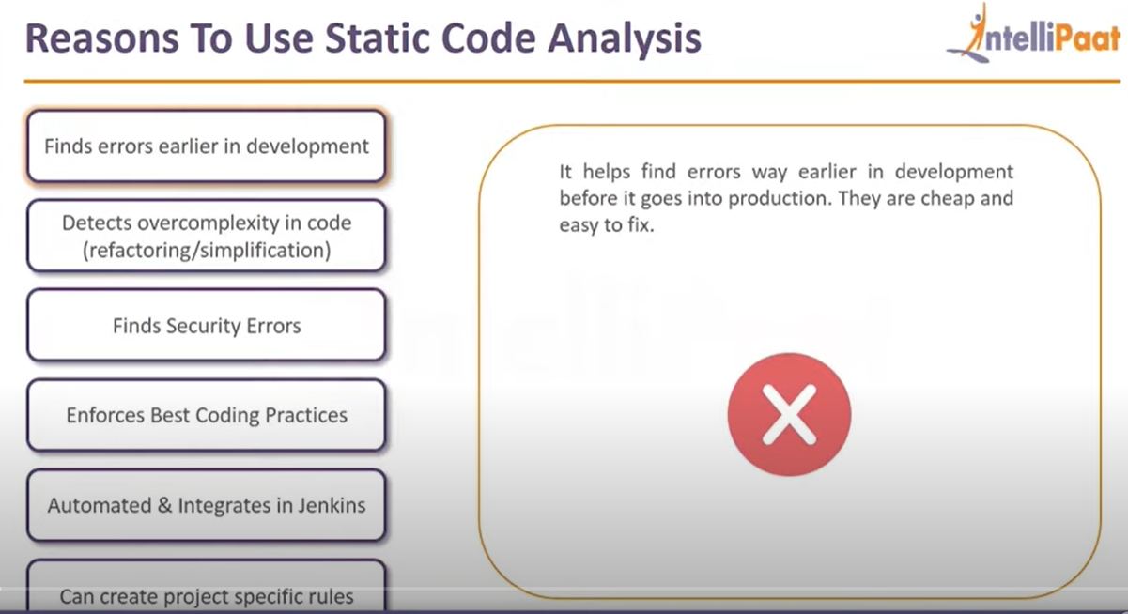

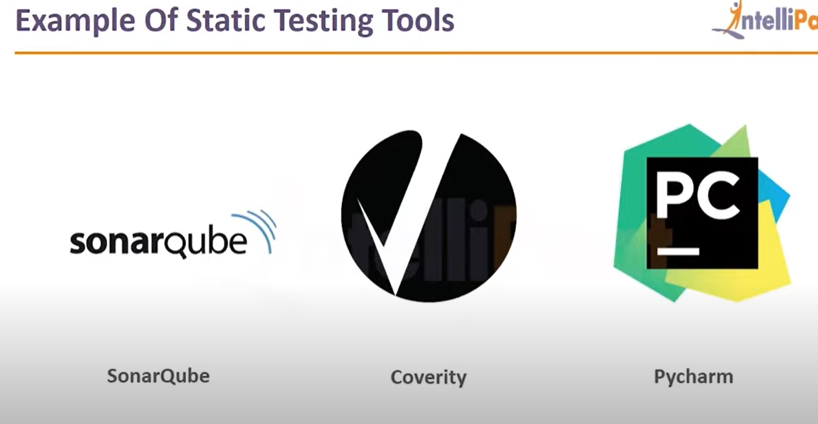

Sonarqube is a static testing analysis tool or quality management tool which goes thru the code written by developer n tries to identify any issues in an early development stage

It is used for

* Code analysis
* Test Reports
* Code Coverage

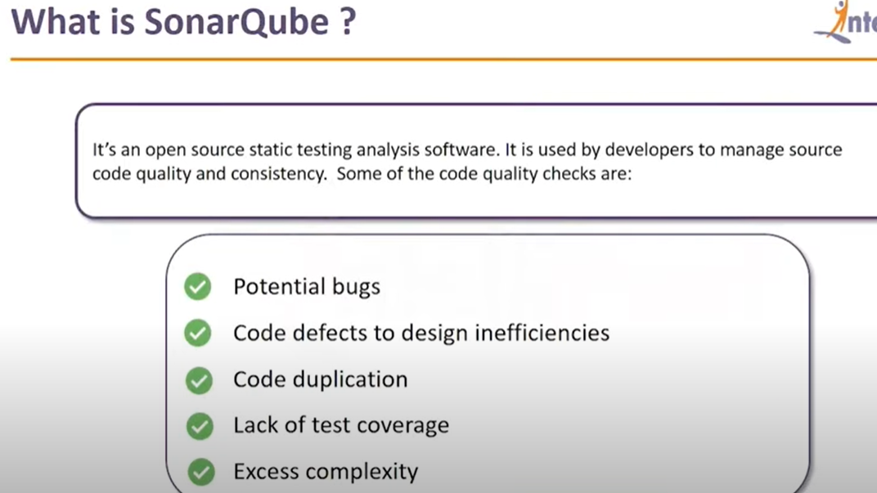

* Features of SonarQube:

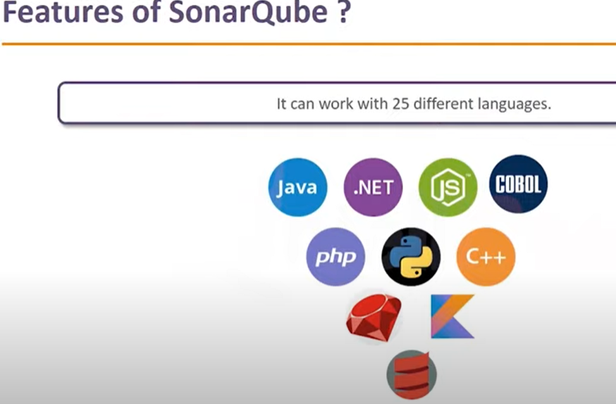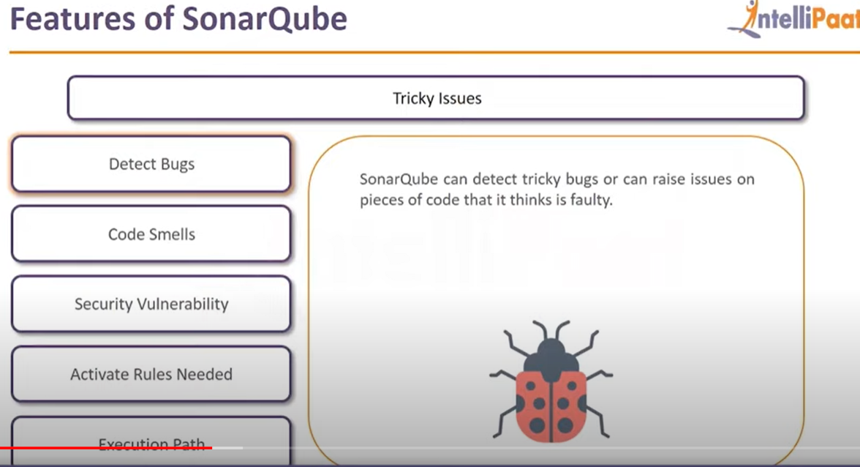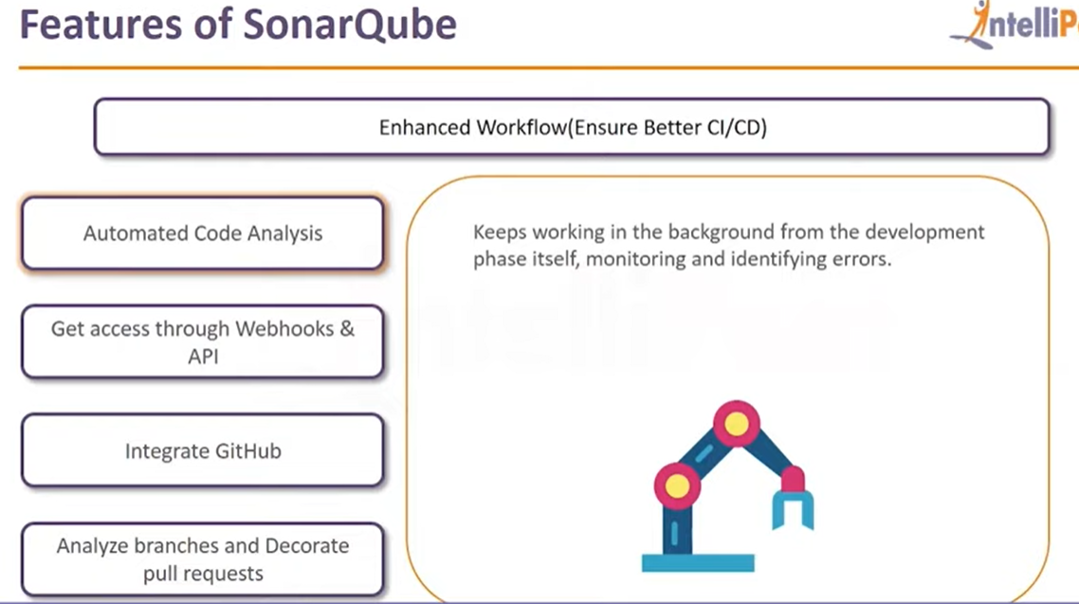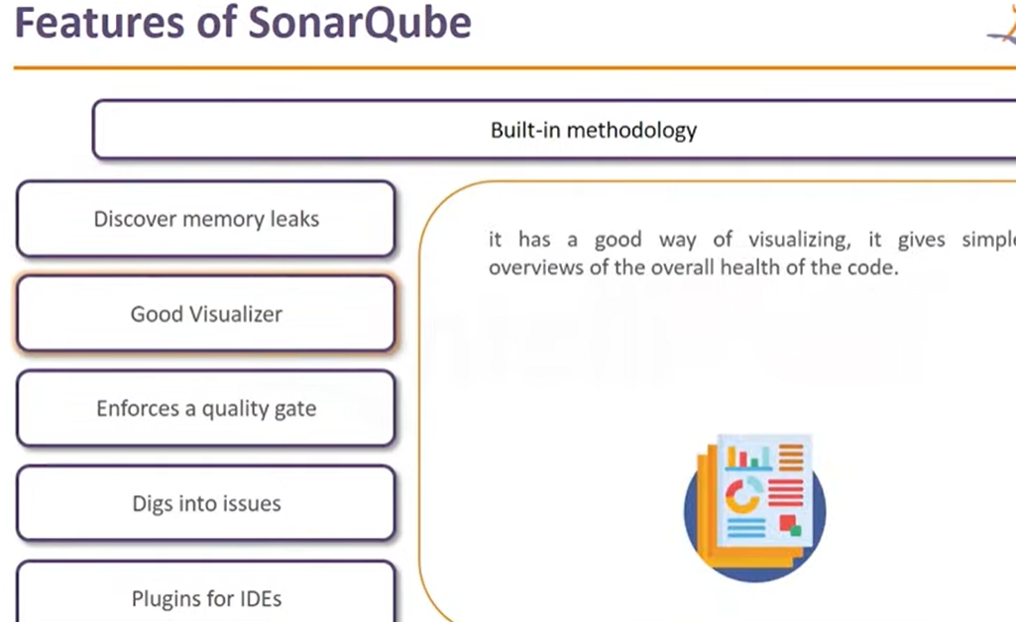

* **Components of Sonarqube:**

1. SonarQube Server

* Rules: rules on which sonarqube runs the ananlysis
* Database: is used to save the result of analysis on db
* Web Interface: used to display the result to users

1. SonarScanner: is an agent which exists on the system where code is there.

**How SonarQube works:**

3.Asks for rules

Rules

1

Src code

Sonarscanner

4. Sends Rules

Web Interface

6. renders Reports

2

User

5. Sends Analysis Reports

db

PC

7. Views report

Sonarqube server

When user executes src code,

* Sonarscanner collects required info from src code(which lang src code is in)
* Sonarscanner Gathers Applicable Rules from SonarQube Server(based on src code lang)
* Apply rules n Generates n sends analysis Reports to sonarqube DB
* The Reports will be displayed on WEB GUI by fetching from DB.

**SonarQube Setup:**

1. Requires Java JDK installed on your system .can be downloaded from [here](https://adoptium.net/en-GB/temurin/releases/?version=11) .After downloading extract the zip file n set the environment variables for Java

JAVA\_HOME=Java jdk path without bin(C:\JDK11\jdk11)

Path=%JAVA\_HOME%\bin

Test java installation via cmd n type java -version

1. Download Sonarqube Community version [here](https://www.sonarqube.org/downloads/) which is free for use.After downloading extract the zip file (*C:\SonarQube) after that go to below path & add that path to Environment variable path*

C:\SonarQube\sonarqube-9.6.1.59531\bin\windows-x86-64

after that to start the SonarQube Server

go to the path C:\SonarQube\sonarqube-9.6.1.59531\bin\windows-x86-64 n double click the StartSonar.bat file

this will open an cmd window where it will prompt that Sonarqube is up n running

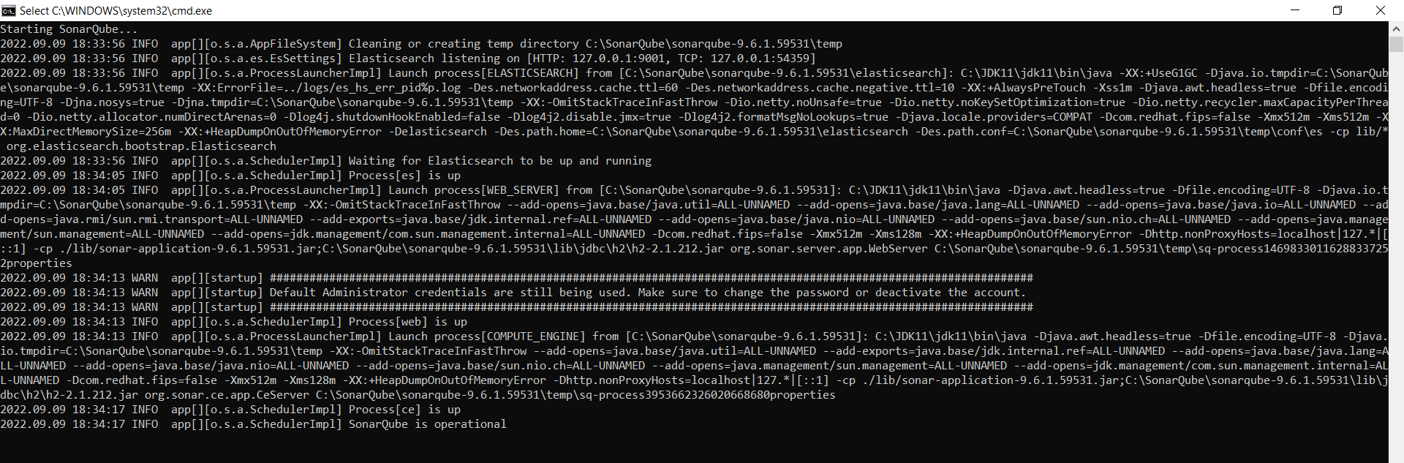

then we need to go to browser n paste below address

<http://localhost:9000/>

if logging first time it will ask for username n password enter

username=admin

password=admin

after that it will ask you to change ur password change it

new password: sonarqube

after that it will prompt create project screen where we can create project or choose from available options

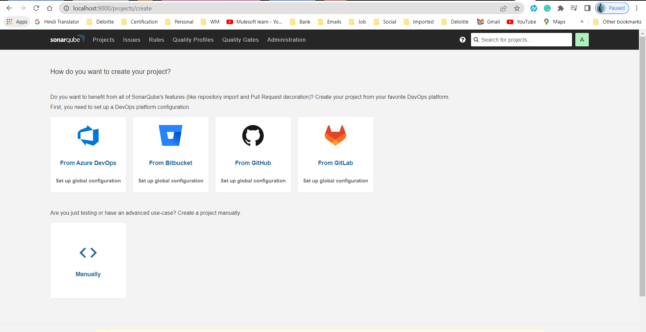

If you want create a project manually then select manually -> on next screen enter display name n click on setup

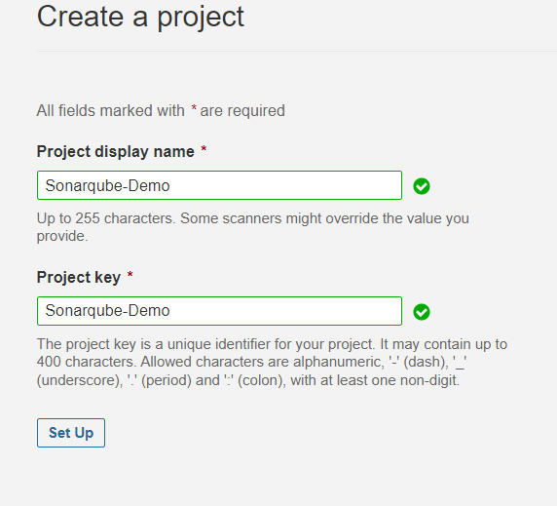

On next screen provide a token

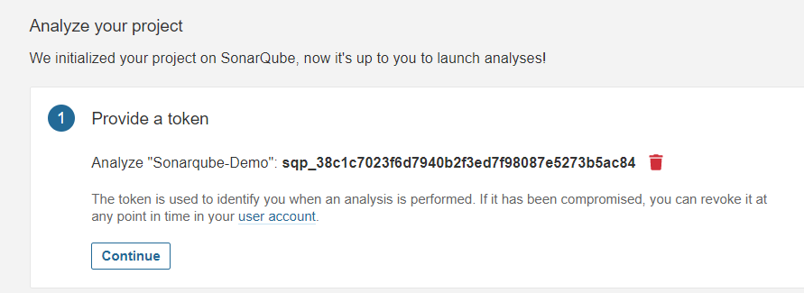

On next screen it asks for language that best describes ur project n based on our option choosen it provides some configuration item to configure in ur project on which u want to run the analysis, 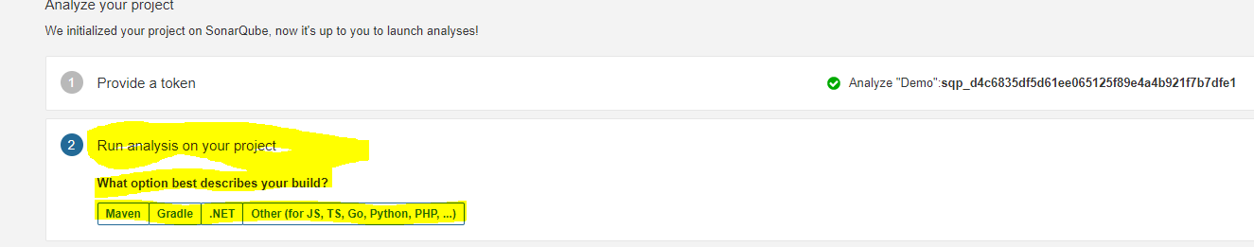

here we selected other option n then choosen our OS so its shown website to download sonarscan file n configuration item.

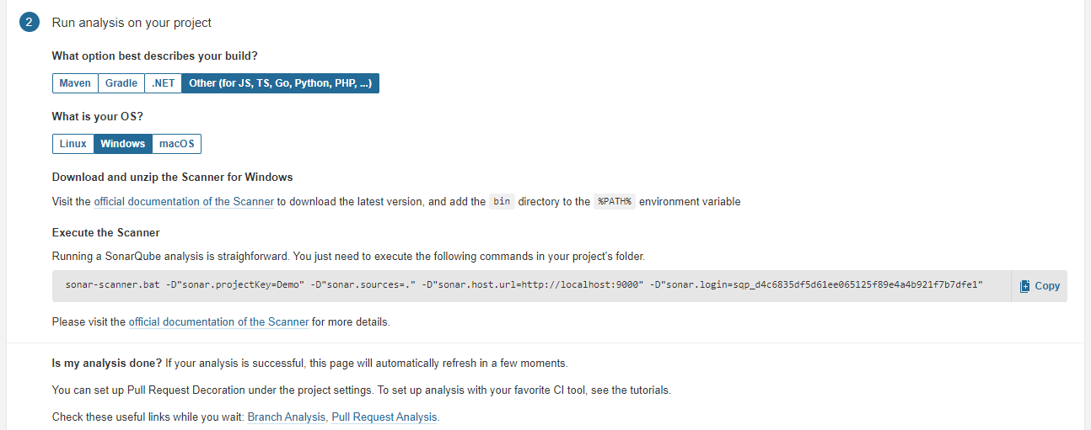

[Download the sonarscan file](https://docs.sonarqube.org/latest/analysis/scan/sonarscanner/) ,it will download the .zip file extract it n set the environment variable to path variable C:\SonarQube\sonar-scanner-4.7.0.2747-windows\bin

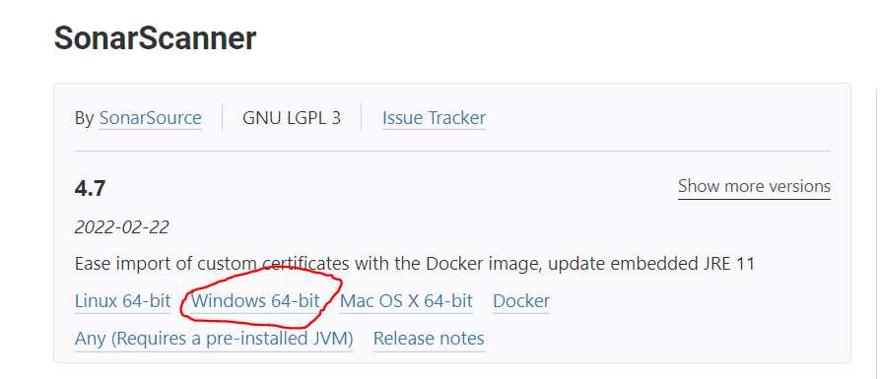

Go to ur project either in prefernceces or in RUN Configurations copy the mentioned command

sonar-scanner.bat -D"sonar.projectKey=sonarqube" -D"sonar.sources=." -D"sonar.host.url=http://localhost:9000" -D"sonar.login=sqp\_cc01f4f5ee22b7867b02f8a3b6e3e5b86e0302b7"

if you have maven In your project then 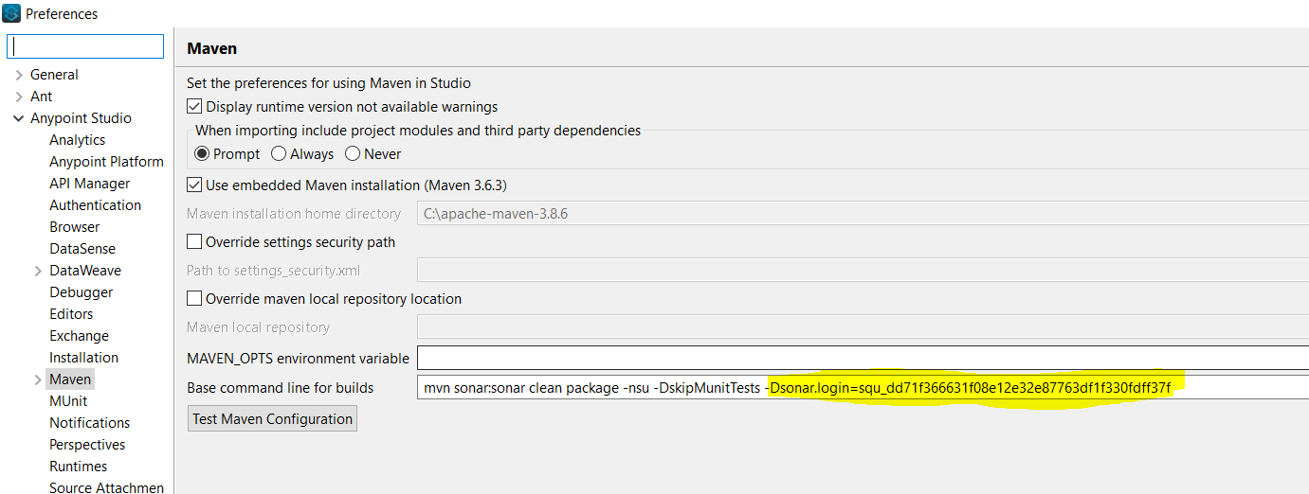

n run the project then the analysis will start its execution like below

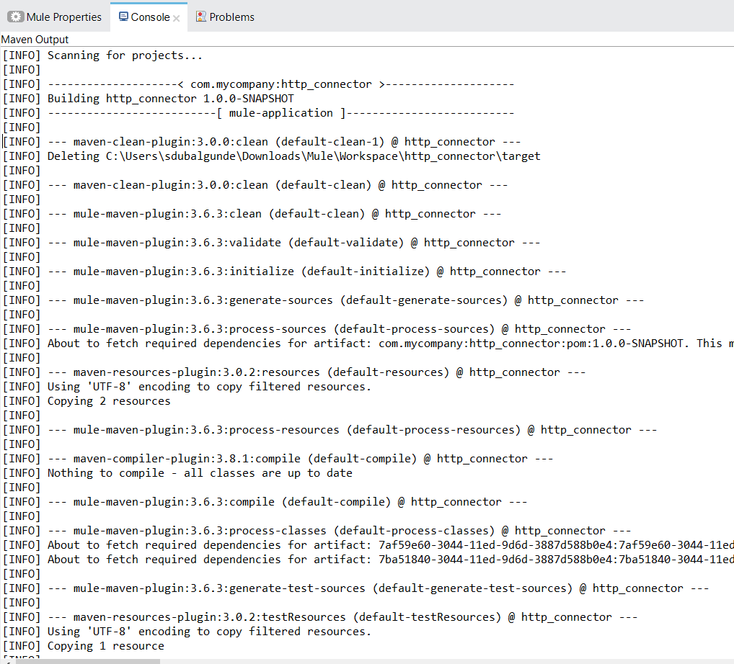 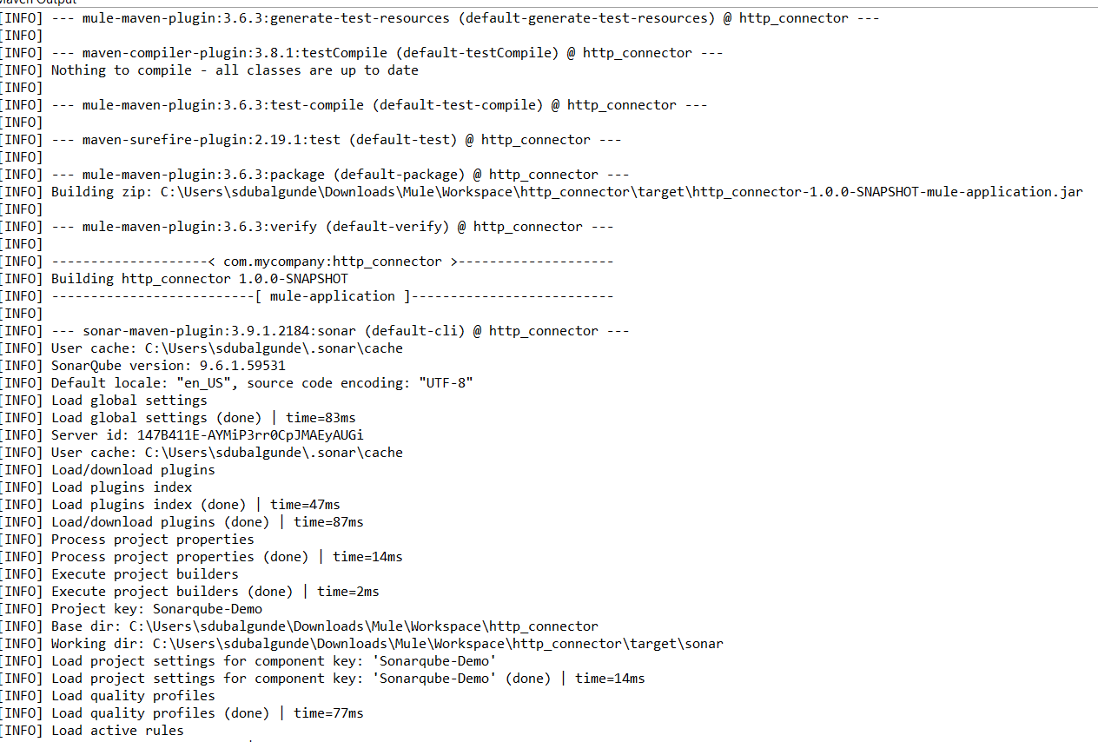 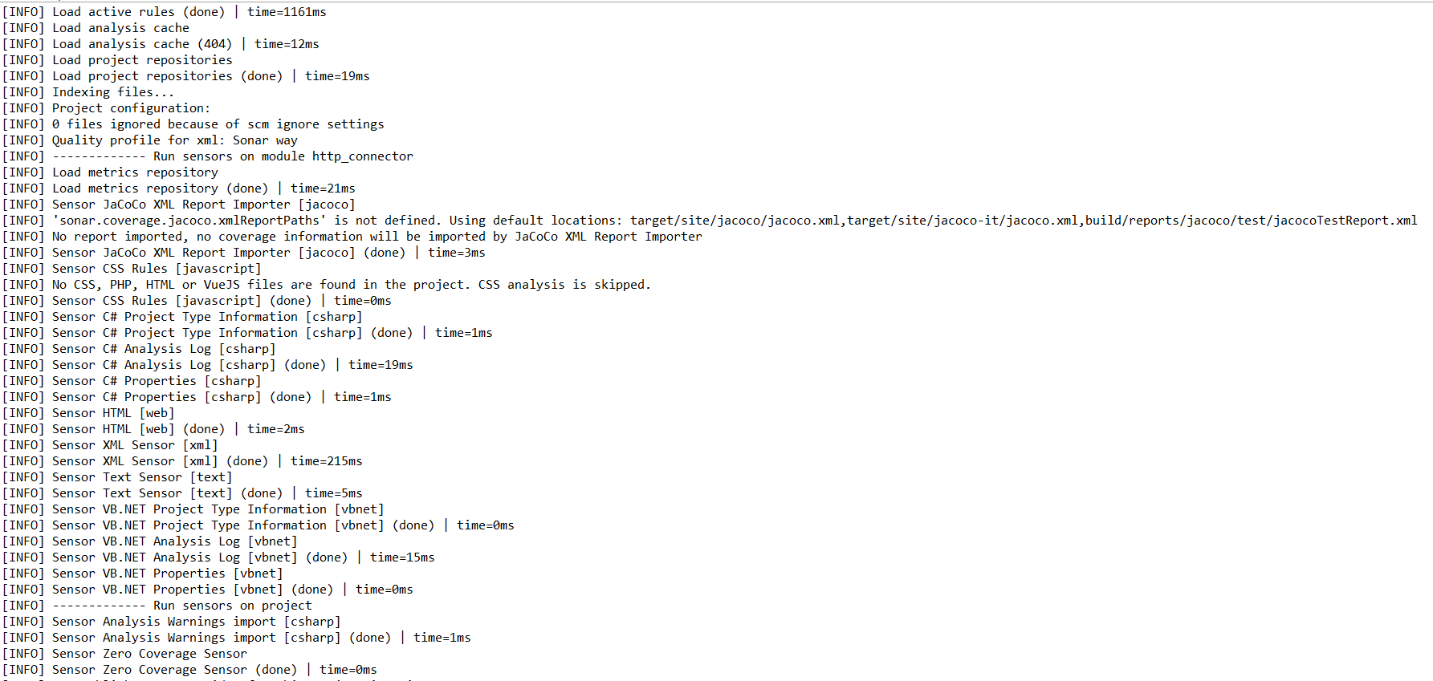 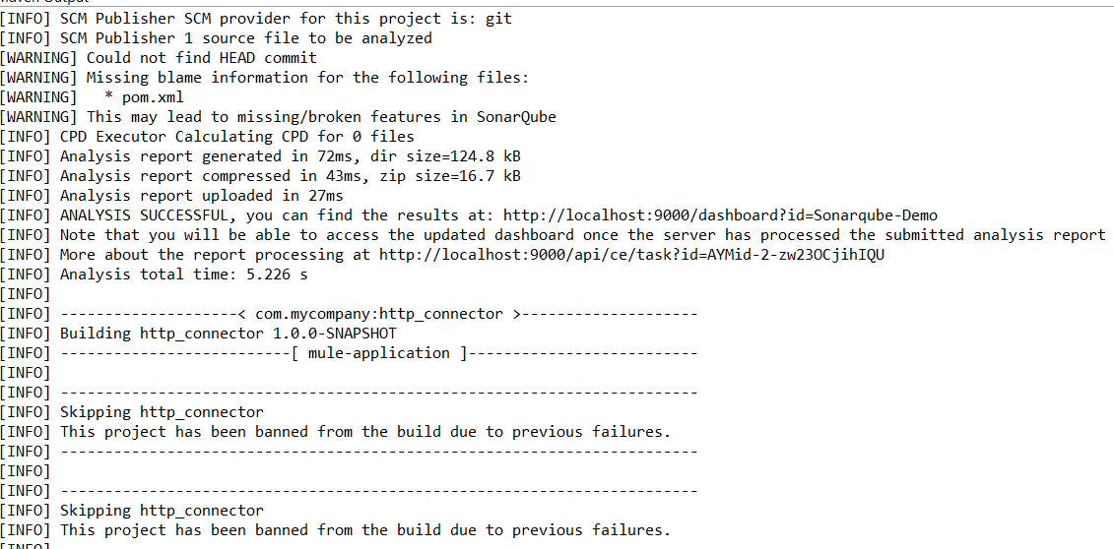

From the logs u can verify that SonarQube version: 9.6.1.59531, Project key: Sonarqube-Demo, Base dir: C:\Users\sdubalgunde\Downloads\Mule\Workspace\http\_connector,

Working dir:C:\Users\sdubalgunde\Downloads\Mule\Workspace\http\_connector\target\sonar,

Load project settings for component key: 'Sonarqube-Demo',Load project settings for component key: 'Sonarqube-Demo' (done) | time=14ms, Quality profile for xml: Sonar way, Analysis report generated in 72ms, dir size=124.8 kB,

Analysis report compressed in 43ms, zip size=16.7 kB,

Analysis report uploaded in 27ms,

ANALYSIS SUCCESSFUL, you can find the results at: http://localhost:9000/dashboard?id=Sonarqube-Demo,

Analysis total time: 5.226 s

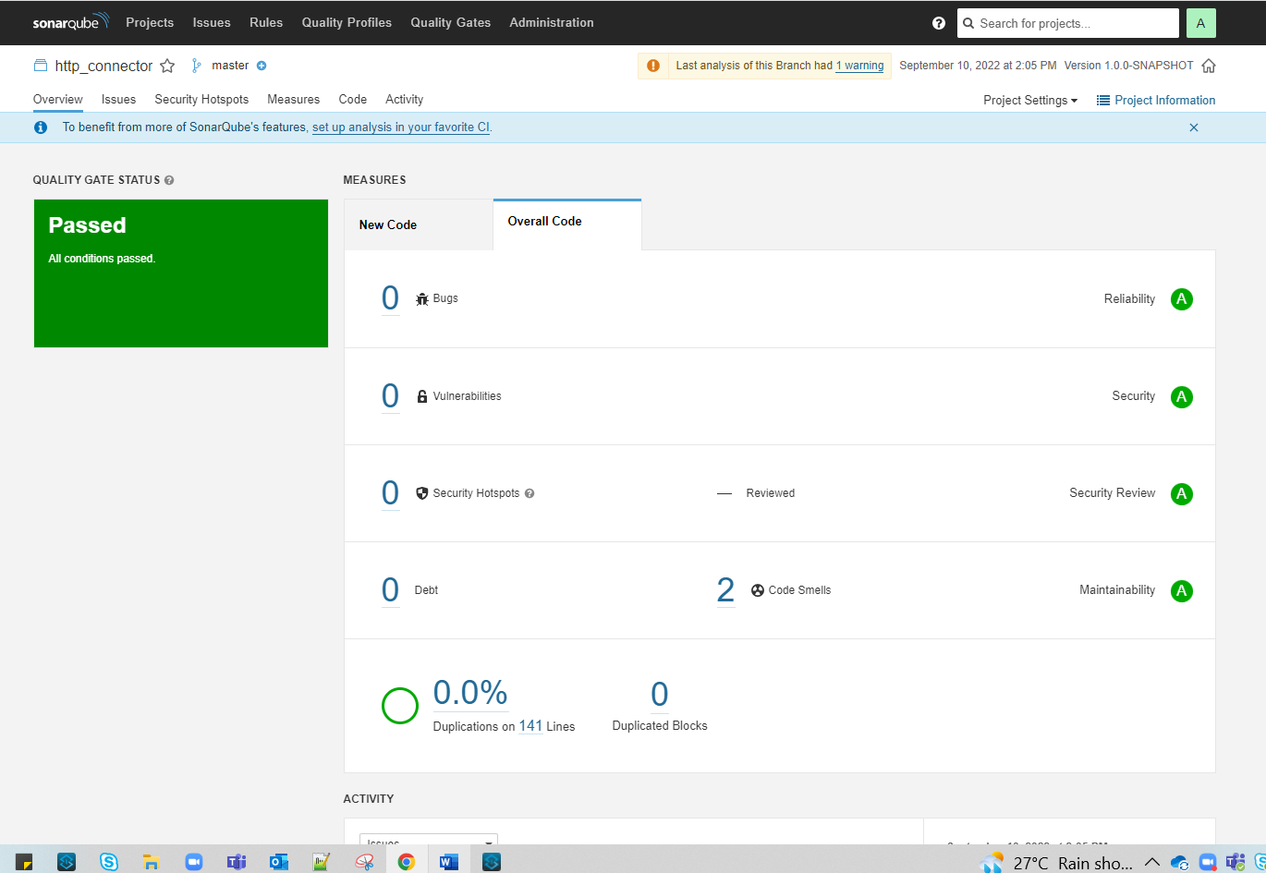

For our purpose of Mule Code Analysis what we can do is we can downloan the sonar maven plugin dependency from [here](https://mvnrepository.com/artifact/org.sonarsource.scanner.maven/sonar-maven-plugin) n add that dependency code in our pom.xml file under <dependencies> and then for connecting with sonarqube server we can add the below highligted argument in our anypoint studio

Windows->preferences->anypoint studio->maven->in command add the below command->Test ->apply

mvn sonar:sonar clean package -nsu -DskipMunitTests -D"sonar.login=squ\_5a8cc48b26c714746cdeb213d80a771834f47a21"

Web Interface overview:-

Main menu BAR:

Projects:shows all projects that are scanned



Issues:Issues in projects

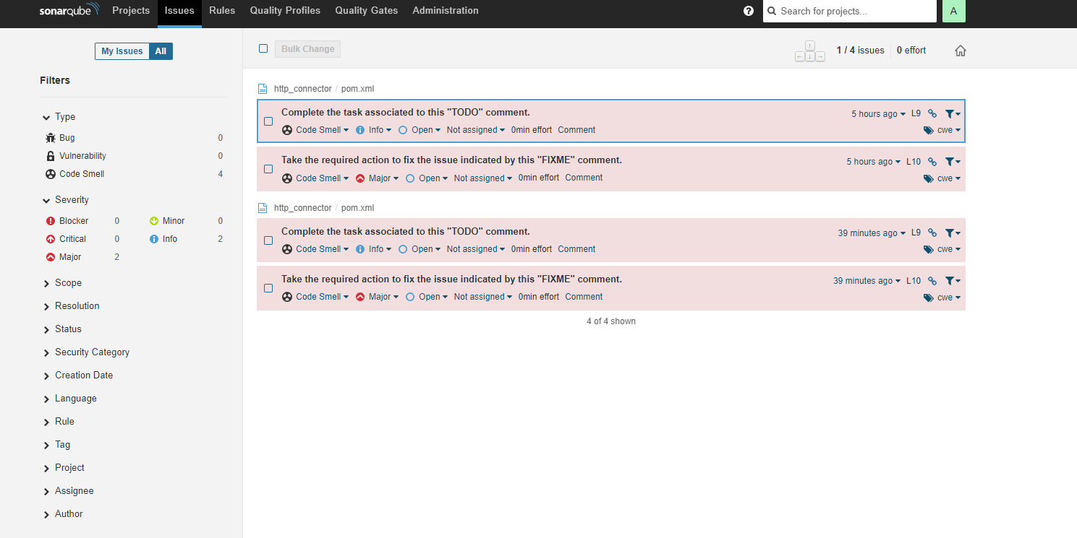

Rules:Rules are checks that been applied on the src code.shows all rules 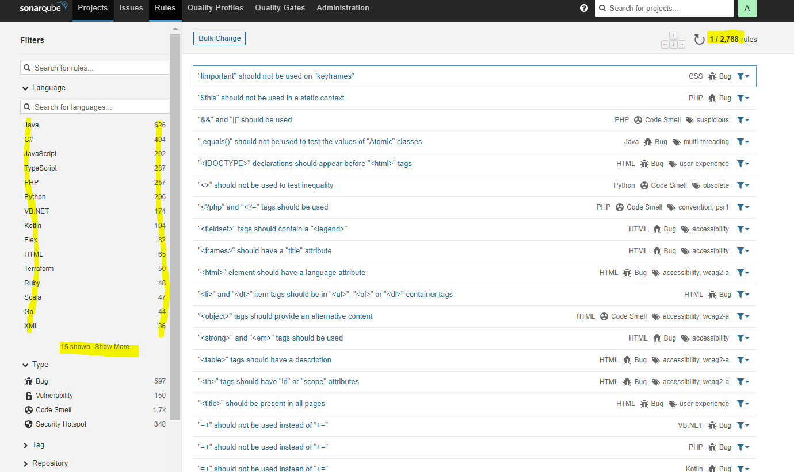

Quality Profiles: Quality Profiles are collections of rules to apply during an analysis.  
For each language there is a default profile. All projects not explicitly assigned to some other profile will be analyzed with the default. Ideally, all projects will use the same profile for a language

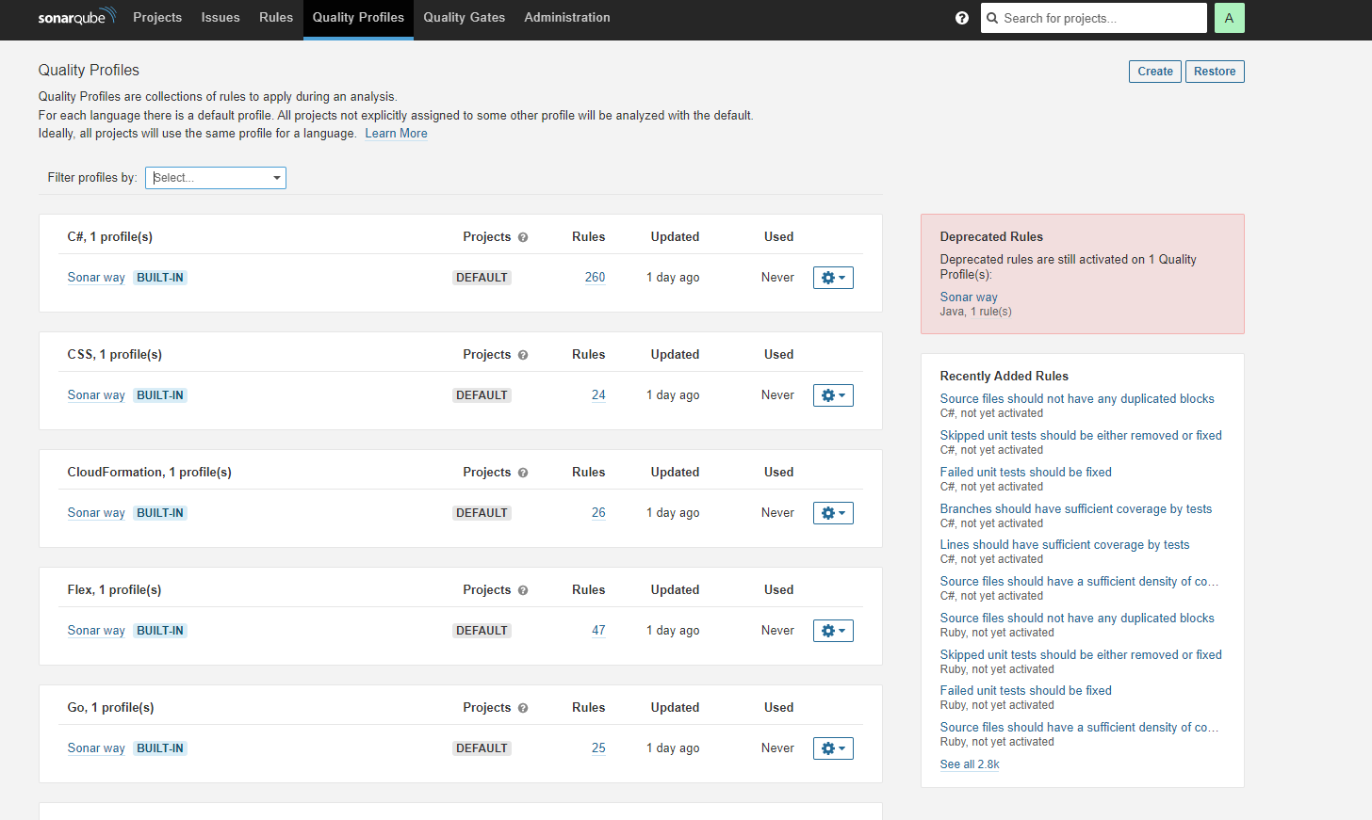

Quality Gates: is specifying the threshold for our project to get pass.

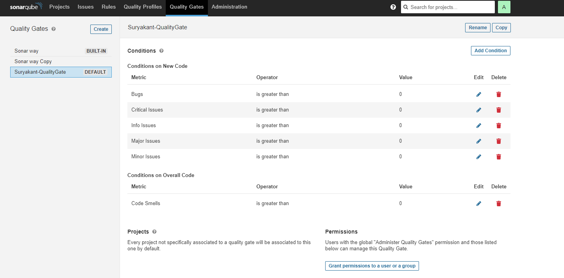

**Static Code Analysis of Mule 4 App with SonarQube Rules**

**Introduction:**

* SonarQube is an open-source platform that is used to analyze the quality of your source code.
* It is written in java but it can analyze the code of more than 20 programming languages using plugins.
* SonarQube will automatically review your code to detect bugs, vulnerabilities, and code smells in your code. We can integrate it with the existing workflow so that it can provide static analysis of your code continuously.
* By default, SonarQube will not validate/analyze the MuleSoft code.
* To analyze the MuleSoft code in SonarQube, we need to add the mule-sonarqube-plugin and basic rules for Mule 4 code to SonarQube which are provided by MuleSoft.

**Mule-sonarqube-plugin generation:**

1. Download the source code from the mulesoft-catalyst GitHub repository https://github.com/mulesoft-catalyst/mule-sonarqube-plugin .
2. To build the mule plugin run the following command in the command prompt,

**mvn clean package sonar-packaging:sonar-plugin -Dlanguage=mule**.

1. Mule-validation-sonarqube-plugin-{version}-mule.jar file will be created in  \*/mule-sonarqube-plugin-master/target folder.

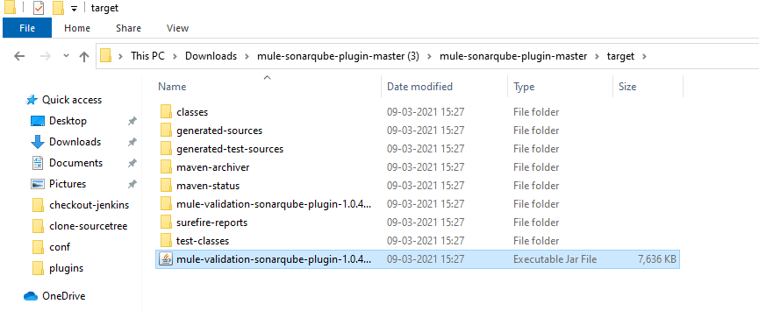

1. Copy this created jar file of the plugin and rules Mule 3 Rules (rules-3.txt) and  Mule 4 Rules (rules-4.txt) from \*/src/test/resources to sonar-home/extensions/plugins

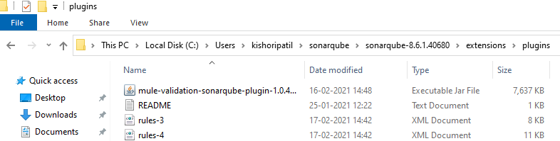

1. The addition of this plugin and rules will create a quality profile in SonarQube called Mule with two set of rules.

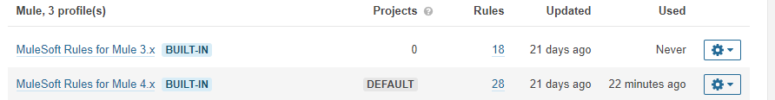

**Create Access token in SonarQube:**

1. Login to your SonarQube and go to my account -> security.
2. Write the name of your token and click generate.

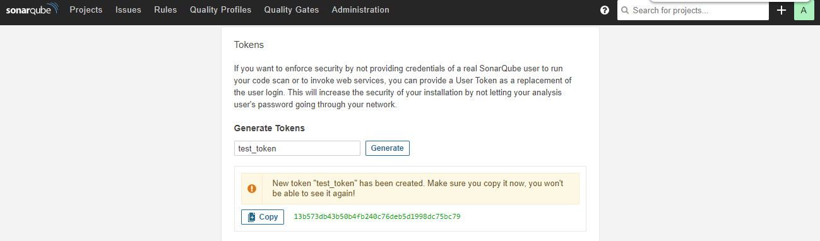

1. Your token will be generated. You have to copy and save this token somewhere. You can use it later.

Suryakant token: squ\_dd71f366631f08e12e32e87763df1f330fdff37f

**Configurations to Analyze your project:**

1. for the server configuration, go to settings.xml file and create new profile as follow:

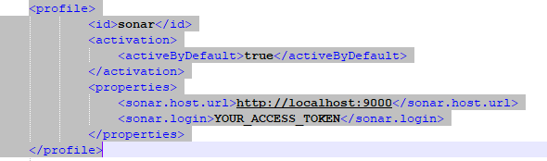

1. It contains the URL on which the SonarQube server is running, and the access token of SonarQube created in the previous step.
2. Add new property and build plugins in the pom.xml of the project as follow:

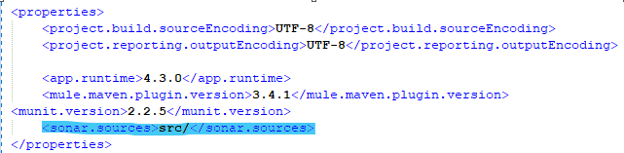

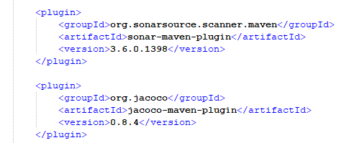

1. Now login to your SonarQube. Go to  Administation -> configuration -> General Settings –> Languages ,select XML in Language and delete .xml from file suffix

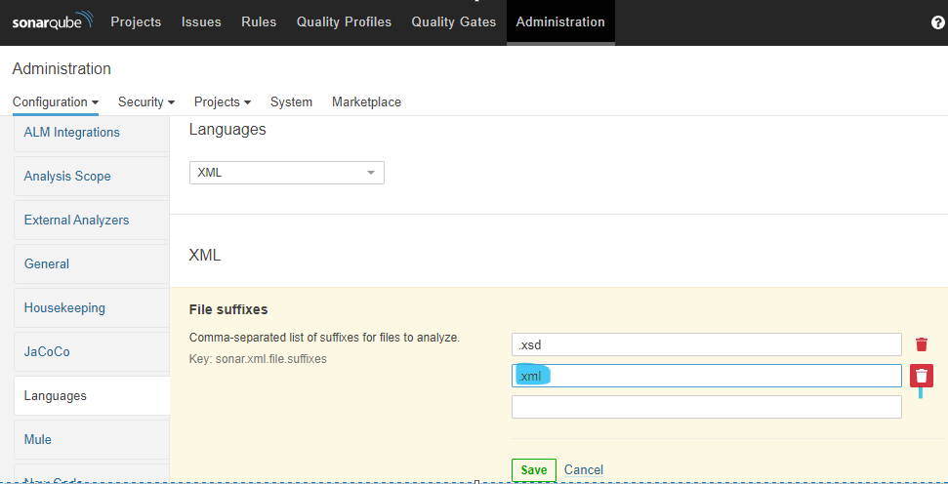

1. We have to delete .xml from there as SonarQube already has a plugin to detect XML code. Now only the mule plugin will detect and analyze .xml code.
2. If you go to Quality Profiles and select Mule profile, you can see Mule 4 rules are set as default by mule-sonarqube-plugin. If you want to analyze the Mule 3 code you have to make Mule 3 rules as default.
3. To analyze your code run the following command by going into anypoint studio->windows->preferences->anypoint studio->maven->configure the below command n run the project

**mvn sonar:sonar -Dsonar.login=squ\_dd71f366631f08e12e32e87763df1f330fdff37f**

other way is to go to the local folder the project->in address bar type cmd ->command prompt will open indicating the project path ->enter the below command to run the analysis

**mvn sonar:sonar -Dsonar.host.url=http://localhost:9000**

**-Dsonar.login=squ\_dd71f366631f08e12e32e87763df1f330fdff37f**

1. Once the build is successful goto sonarqube account project tab you can see the project analysis result. It is passed or failed depending upon the Quality gates defined.

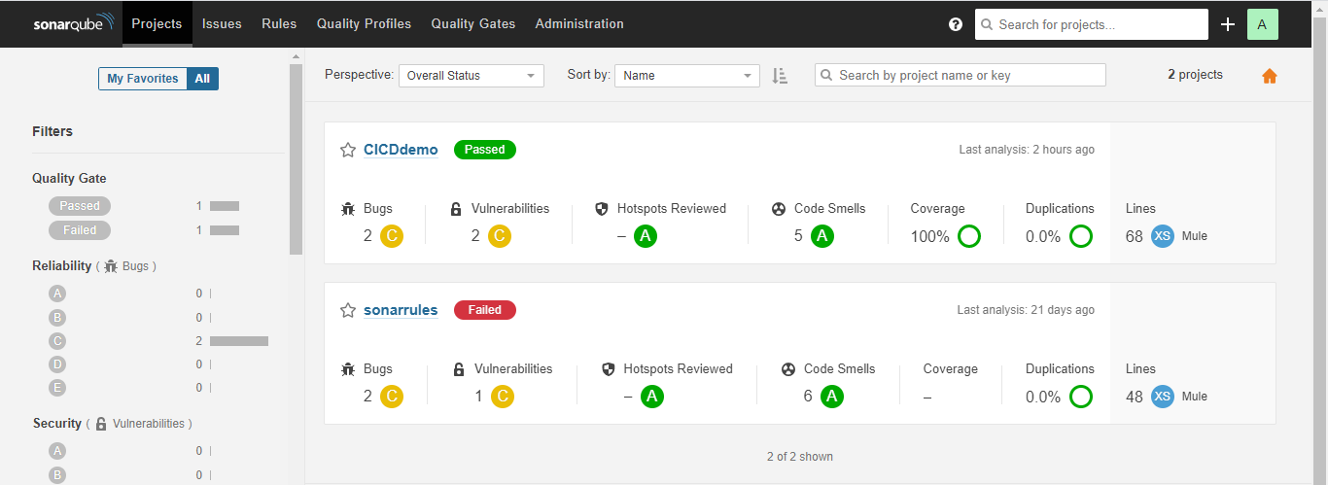

1. In Issue, you can see which rules are not followed by your application. You can make changes according to that.

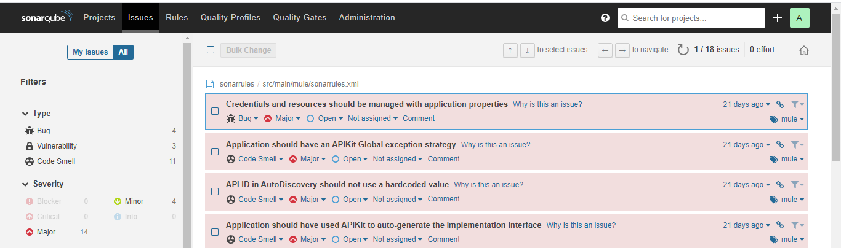

1. You can create your own rules and quality gates according to your need.

# Easiest way to integrate automatic code review of MuleSoft apps using SonarQube and Docker Container

Updated: Sep 4, 2021

[[](https://unsplash.com/photos/d9ILr-dbEdg)](https://unsplash.com/photos/d9ILr-dbEdg" \t "_blank)

[Photo by Agence Olloweb on Unsplash.](https://unsplash.com/photos/d9ILr-dbEdg" \t "_blank)

## **Using SonarQube and Docker**

The quickest way to have an installation of SonarQube up and running is using a Docker container. SonarQube is a platform for continuous inspection of code quality to perform automatic reviews with static analysis of code to detect bugs, [code smells](https://en.wikipedia.org/wiki/Code_smell) and security vulnerabilities. This definition is not by me, it is from Wikipedia (<https://en.wikipedia.org/wiki/SonarQube>).

If you want to know more about SonarQube and all its capabilities, you can visit their website:

[https://www.sonarqube.org/](https://www.sonarqube.org/developer-edition/?gads_campaign=South-America-SonarQube&gads_ad_group=SonarQube&gads_keyword=sonarqube&gclid=Cj0KCQjwvYSEBhDjARIsAJMn0lga8FBAQxpXuiDOFvD4zK28tuA1_8TlLkBTOtDcFaWIahnsU2DtyKUaAgbGEALw_wcB)

On the other hand, Docker delivers software in packages called containers (they are ready to use). It is very cool, isn’t it? If you want to learn more about Docker, please visit their website:

<https://www.docker.com/>

## **Docker Hub**

Let’s use Docker Hub (the world’s largest library and community for container images) to find a SonarQube Docker container to perform our MuleSoft applications code reviews.

Step by step:

1. Go to Docker Hub: <https://hub.docker.com/>
2. Sign in (or sign up if you do not have an account already)
3. Download the following image: mulesonarqube
4. Run the Docker image.

That is all! Now you have a SonarQube instance up and running, and it is ready to perform MuleSoft code analysis.

## **SonarQube Docker Container**

To download the Docker image (it will take a while):

docker pull fperezpa/mulesonarqube:7.7.3

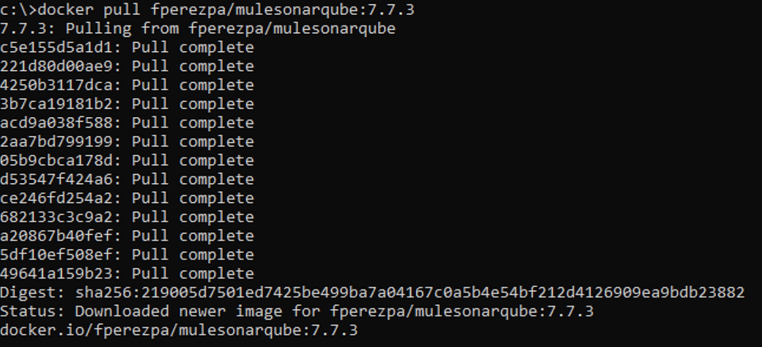

To run the Docker image:

docker run -d --name sonarqube -p 9000:9000 -p 9092:9092 fperezpa/mulesonarqube:7.7.3

You should see something like this in your command line:



Or in your Docker Desktop:

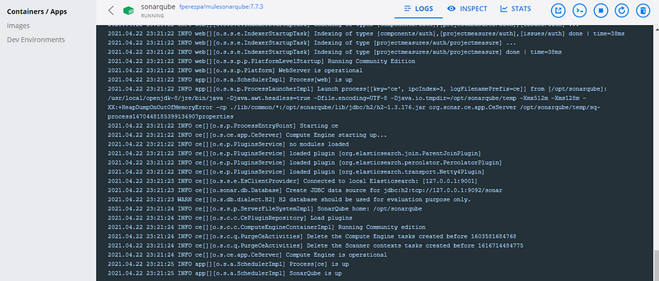

If you want to know more about Docker Desktop (available for Windows, Mac and Linux), visit this website: <https://www.docker.com/products/docker-desktop>

## **Go to your SonarQube instance**

That is it! Your SonarQube instance is ready to use.

Go to: <http://localhost:9000/projects> (use admin/admin as default username and password to Log In, you can change it later).

You should see something like this:

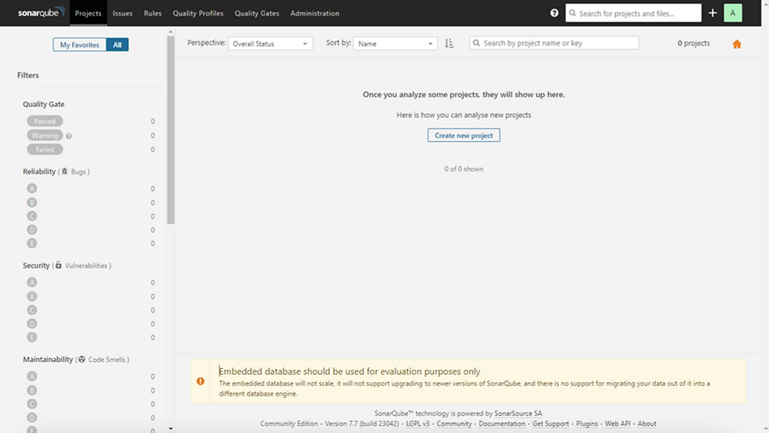

There is a set of Rules already configured in your SonarQube instance to analyze MuleSoft code. You can find those clicking on Rules (top menu) and then on Mule (left menu). If you are feeling lucky you can modify those rules as needed.

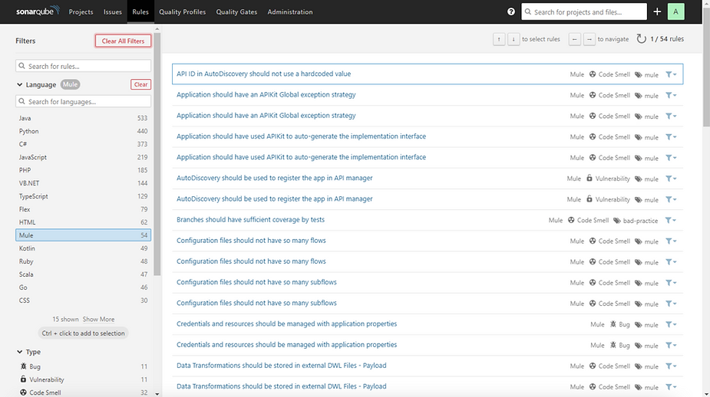

There are two Quality Profiles: one for Mule 4 applications and another one for Mule 3 applications. The default Quality Profile is Mule 4.

Explore it by clicking on Quality Profiles (top menu) and then filtering profiles by Mule (picking list).

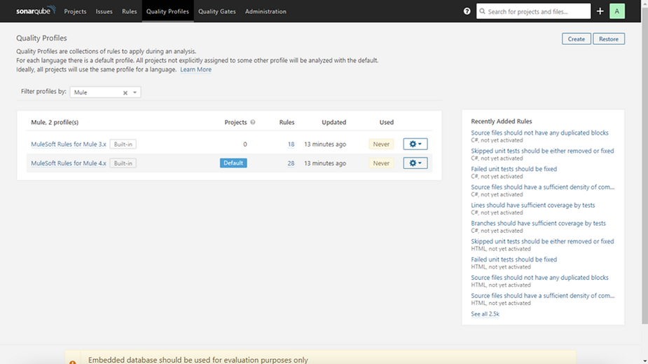

Continue exploring your SonarQube, enjoy the trip!

## **Important! XML configuration**

SonarQube already comes with an XML plugin. But…Your MuleSoft code is also XML. The plugin we are going to use inspects XML files, so you need to remove the XML files from the default XML plugin in SonarQube. This will avoid the XML plugin checks for your MuleSoft application and lets the Mule plugin into action.

To do that, click on Administration (top menu), then Configuration and General Settings (top left menu), click on XML (left menu) and remove the .xml extension from the XML plugin configuration. You should see something like this (click on the red cross to remove .xml line):

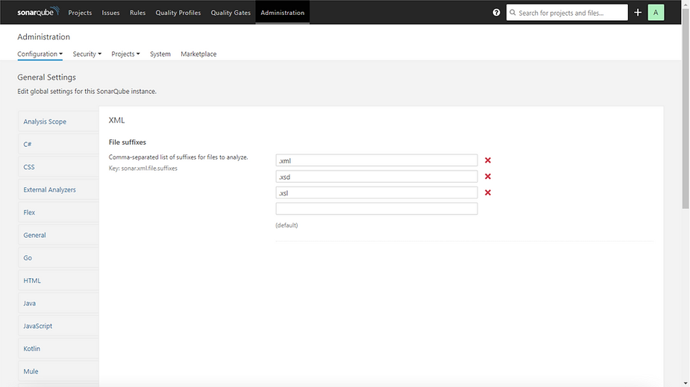

Then click on the Save button and you are done! Your SonarQube is ready to check your MuleSoft code.

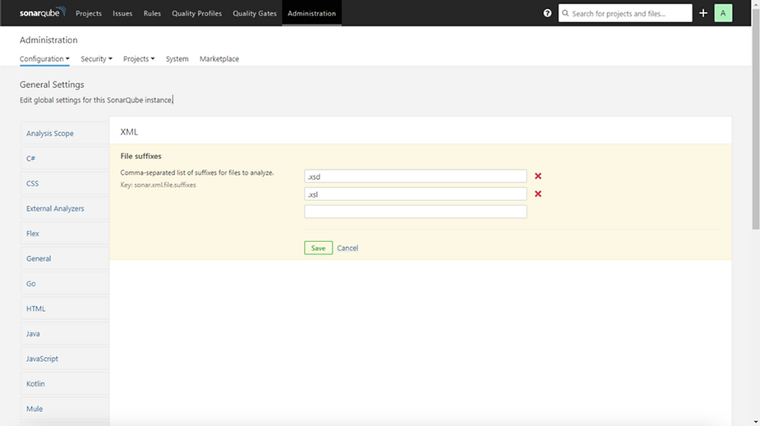

## **Use the Maven Plugin**

We are about to use a Maven plugin to verify the quality of our MuleSoft code using SonarQube. This plugin contains a set of rules and metrics that are going to be used and calculated every time a project is being inspected. This is a plugin developed by MuleSoft and it is unlicensed.

If you want to know more about this plugin, please refer to the official repository:

<https://github.com/mulesoft-catalyst/mule-sonarqube-plugin>

To use this plugin, open a command line and navigate to your MuleSoft project’s home directory and run the following command:

mvn sonar:sonar -Dsonar.host.url=http://localhost:9000 -Dsonar.sources=.\src

* -Dsonar.host.url is the URL where your SonarQube instance is running.
* -Dsonar.sources is the path where the code to analyze is (typically src folder under your MuleSoft project home).

I have quickly created a Kafka producer-consumer MuleSoft app and I will analyze this code.

You should see something like the following:

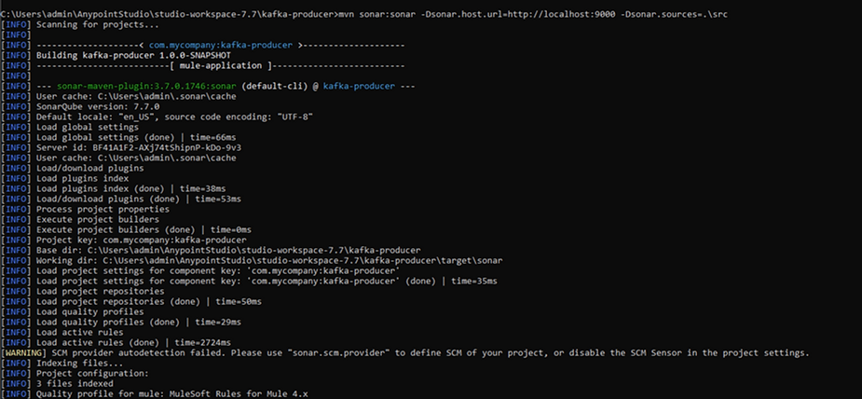

Finally, the plugin completes the code analysis, and the report will be available at your SonarQube instance:

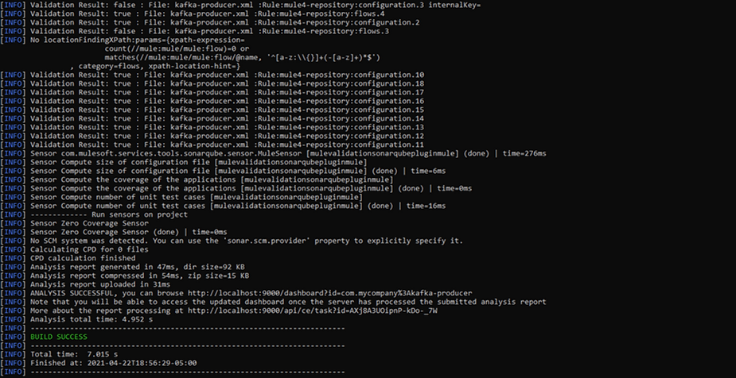

## **SonarQube Report**

You will find the report in your SonarQube instance. Just navigate to Projects (top menu), you should see your project there.

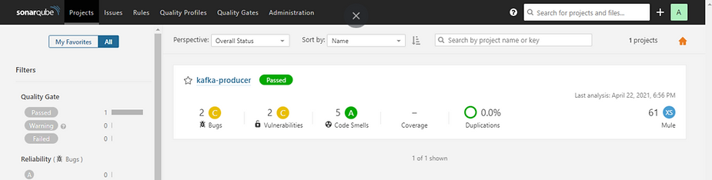

Click on your project and explore the report details.

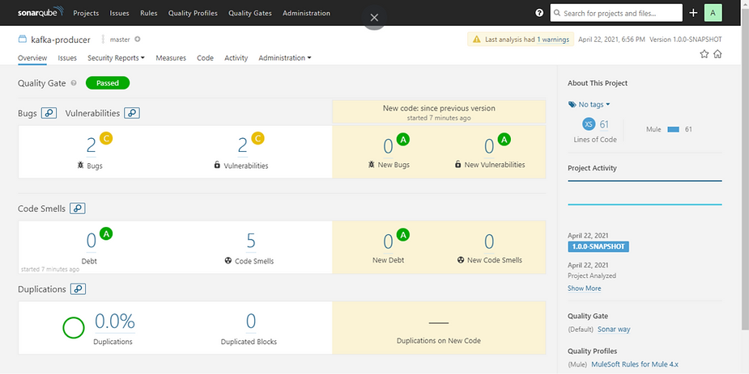

Let’s take a quick look at the Bugs section.

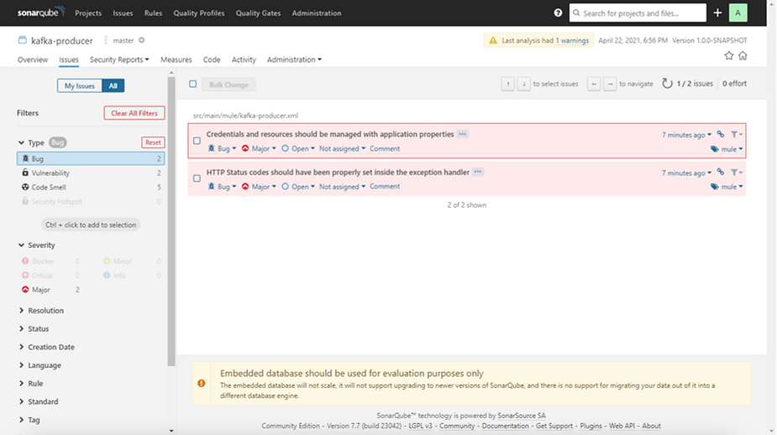

## **Conclusion**

The report is highlighting a bug that says that credentials and resources should be managed with application properties. This was intentional. The application has an HTTP Listener with hardcoded host and port values. This is not a good practice to develop MuleSoft applications, those should be placed in a properties file.

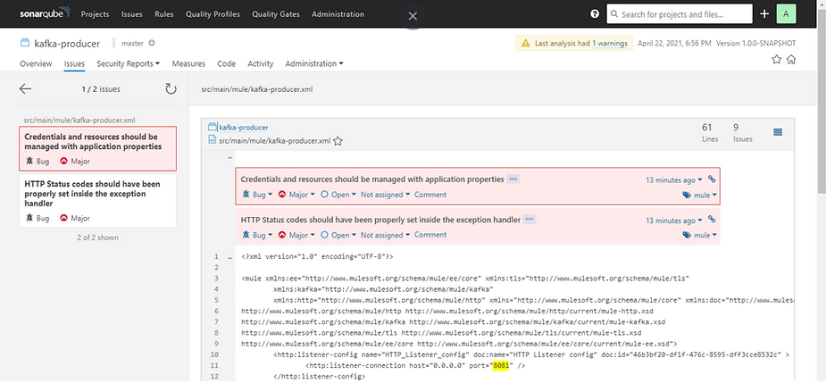

You can also explore the Mule default Rules definition in your SonarQube instance and modify/add rules as needed. If you have different MuleSoft coding standards you can enrich that set of rules.

This is the first step to semi-automate code reviews for MuleSoft projects. After this you can integrate this Maven plugin with a CI/CD pipeline. This is very cool, right?

**Integrate Sonarqube with Jenkins**

Reference Doc for this step: <https://github.com/sdubalgunde/DevOps/blob/master/sonarqube/integrate_sonar_with_jenkins.md>

# Integrate Sonarqube with Jenkins

## 🧰 Prerequisites

1. a Sonarqube Server [[Click here to Setup Sonarqube server]](https://github.com/sdubalgunde/DevOps/blob/master/sonarqube)

(Sonarqube server should be setup n should be UP n Running.)

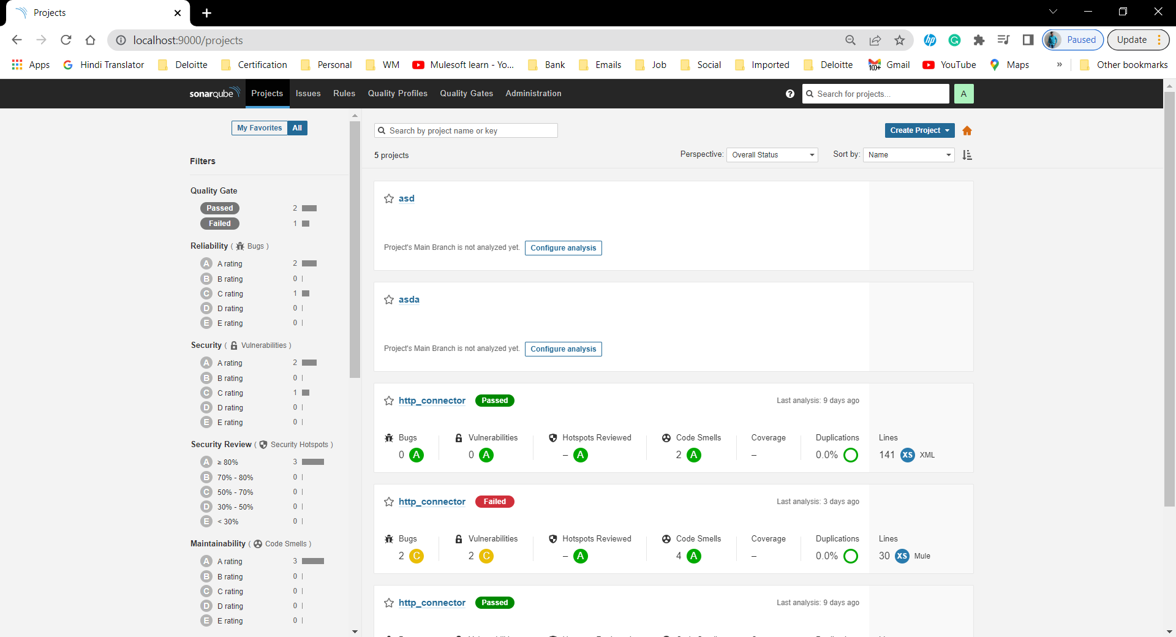

1. A Jenkins server [[Click here to set up a Jenkins server]](https://github.com/sdubalgunde/DevOps/blob/master/sonarqube)

(Jenkins server should be setup n should be UP n Running.)

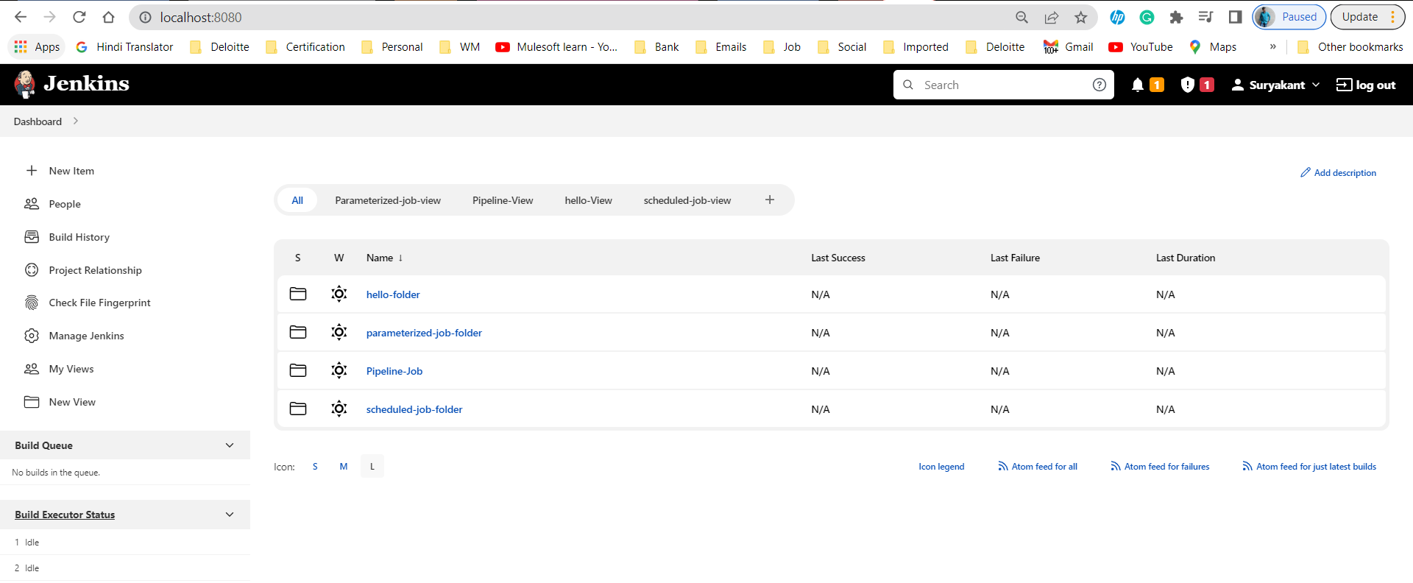

Integration Steps

### On Sonarqube server

* 1. Generate a sonarqube token to authenticate from Jenkins

Go to Sonarqube UI->Click on Profile picture(Top right Side)->My Account->Security->Tokens->Generate Tokens

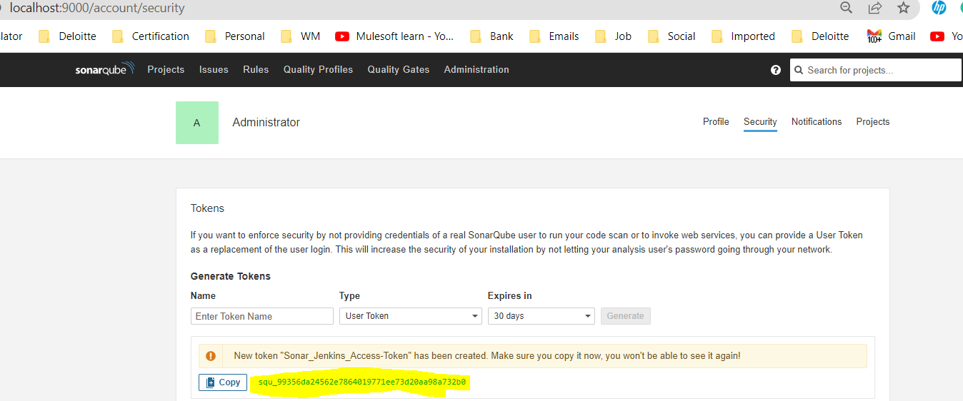

squ\_99356da24562e7864019771ee73d20aa98a732b0

### On Jenkins server

1. Install Sonarqube plugin

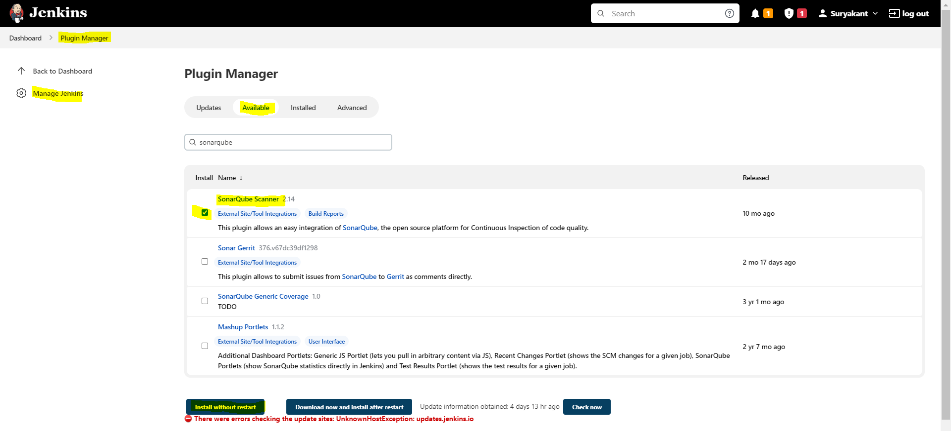

1. Configure Sonarqube credentials

Jenkins Dashboard->Manage Jenkins->Manage Credentials->select ‘ Jenkins’ under Stores scoped to Jenkins->Global Credentials(Unrestricted)->Click on Add Credentials->fill the details->Create

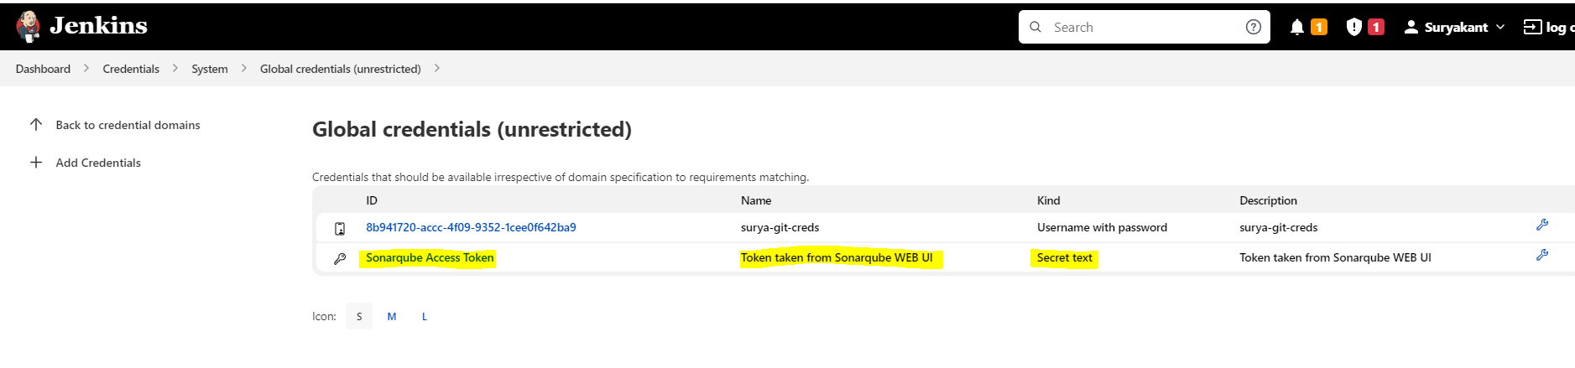

1. Add Sonarqube to jenkins "configure system"

To add sonarqube to Jenkins we need to go to Jenkins Dashboard->Manage Jenkins->Configure System->Go to Sonarqube Server->Check the Environment variable box-> click on Add Sonarqube-> provide details like Name:sonarqube-9.6.1,Server <Url:http://localhost:9000,Server> Authentication token:from dropdown select the creds you created in the previous step.->Apply ->Save.

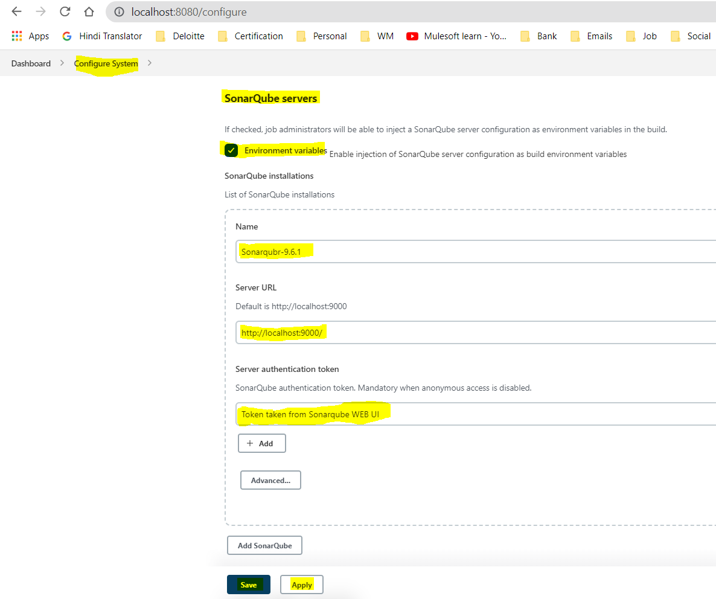

1. Install SonarScanner

To install SonarScanner in Jenkins,go to Jenkins Dashboard->Manage Jenkins->Global Tool Configuration->SonarQube Scanner->Provide details name:SonarQubeScanner-4.7.0,Check install automatically->Apply ->Save.

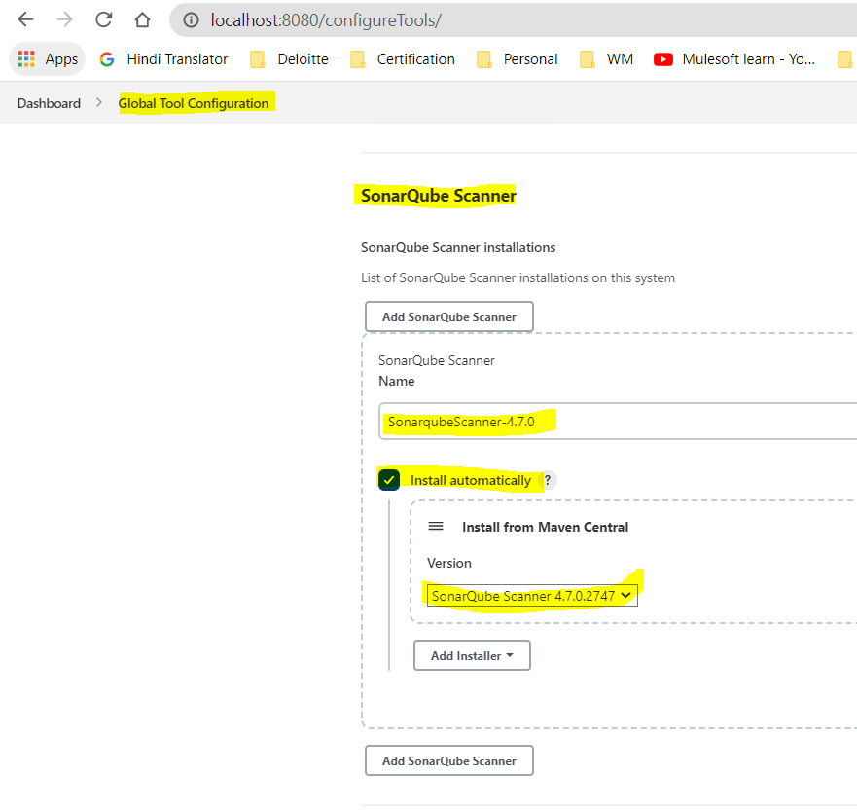

1. Run Pipeline job

To create a pipeline job, Jenkins Dashboard->New Item->Give name,select Pipeline Job->Create->In Pipeline Script add below:

While Running a Jenkins job if u get below error java.io.IOException: Cannot run program "nohup" (in directory "C:\ProgramData\Jenkins\.jenkins\workspace\Sonar-Jen-pipelineJob"): CreateProcess error=2, The system cannot find the file specified

To solve this issue,we need to replace ‘sh’ with bat as windows don’t support linux cmds n ‘sh’ is linux cmd n ‘bat’ is window cmd.

For eg:

stage('Build'){

steps{

sh 'mvn clean package'

}

sh will be replaced by bat

stage('Build'){

steps{

bat 'mvn clean package'

}

pipeline{

agent any

environment {

PATH = "$PATH:apache-maven-3.8.6\bin"

}

stages{

stage('GetCode'){

steps{

git 'https://github.com/sdubalgunde/Mulesoft\_Learning.git'

}

}

stage('Build'){

steps{

bat 'mvn clean package'

}

}

stage('SonarQube analysis') {

// def scannerHome = tool 'SonarScanner 4.0';

steps{

withSonarQubeEnv('Sonarqube-9.6.1') {

// If you have configured more than one global server connection, you can specify its name

//Sonarqubr-9.6.1 is the name of sonar system we configured in manage Jenkins->Configure System

// bat "${scannerHome}/bin/sonar-scanner"

bat "mvn sonar:sonar"

}

}

}

}

}

Then apply n save ->run the build by clicking on Build Now.

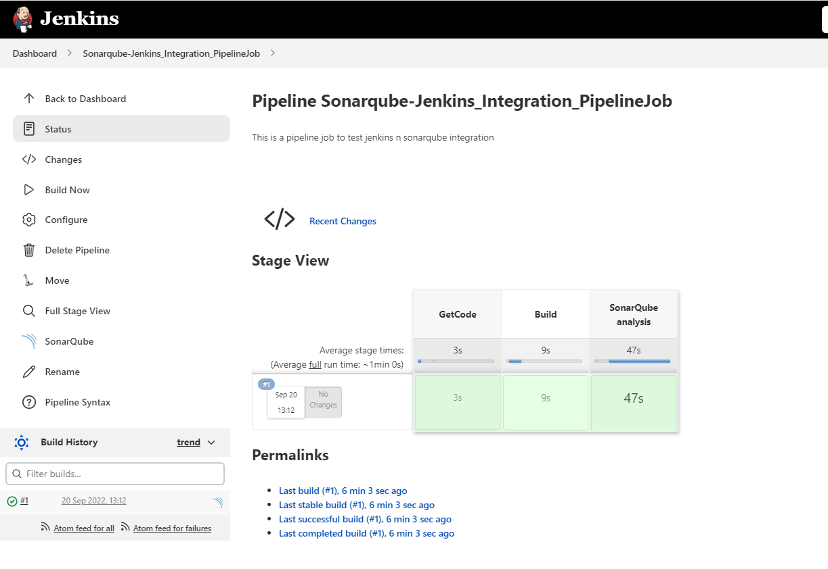

In Sonarqube Web UI, you will be able to see the Analysis report generated for the project.

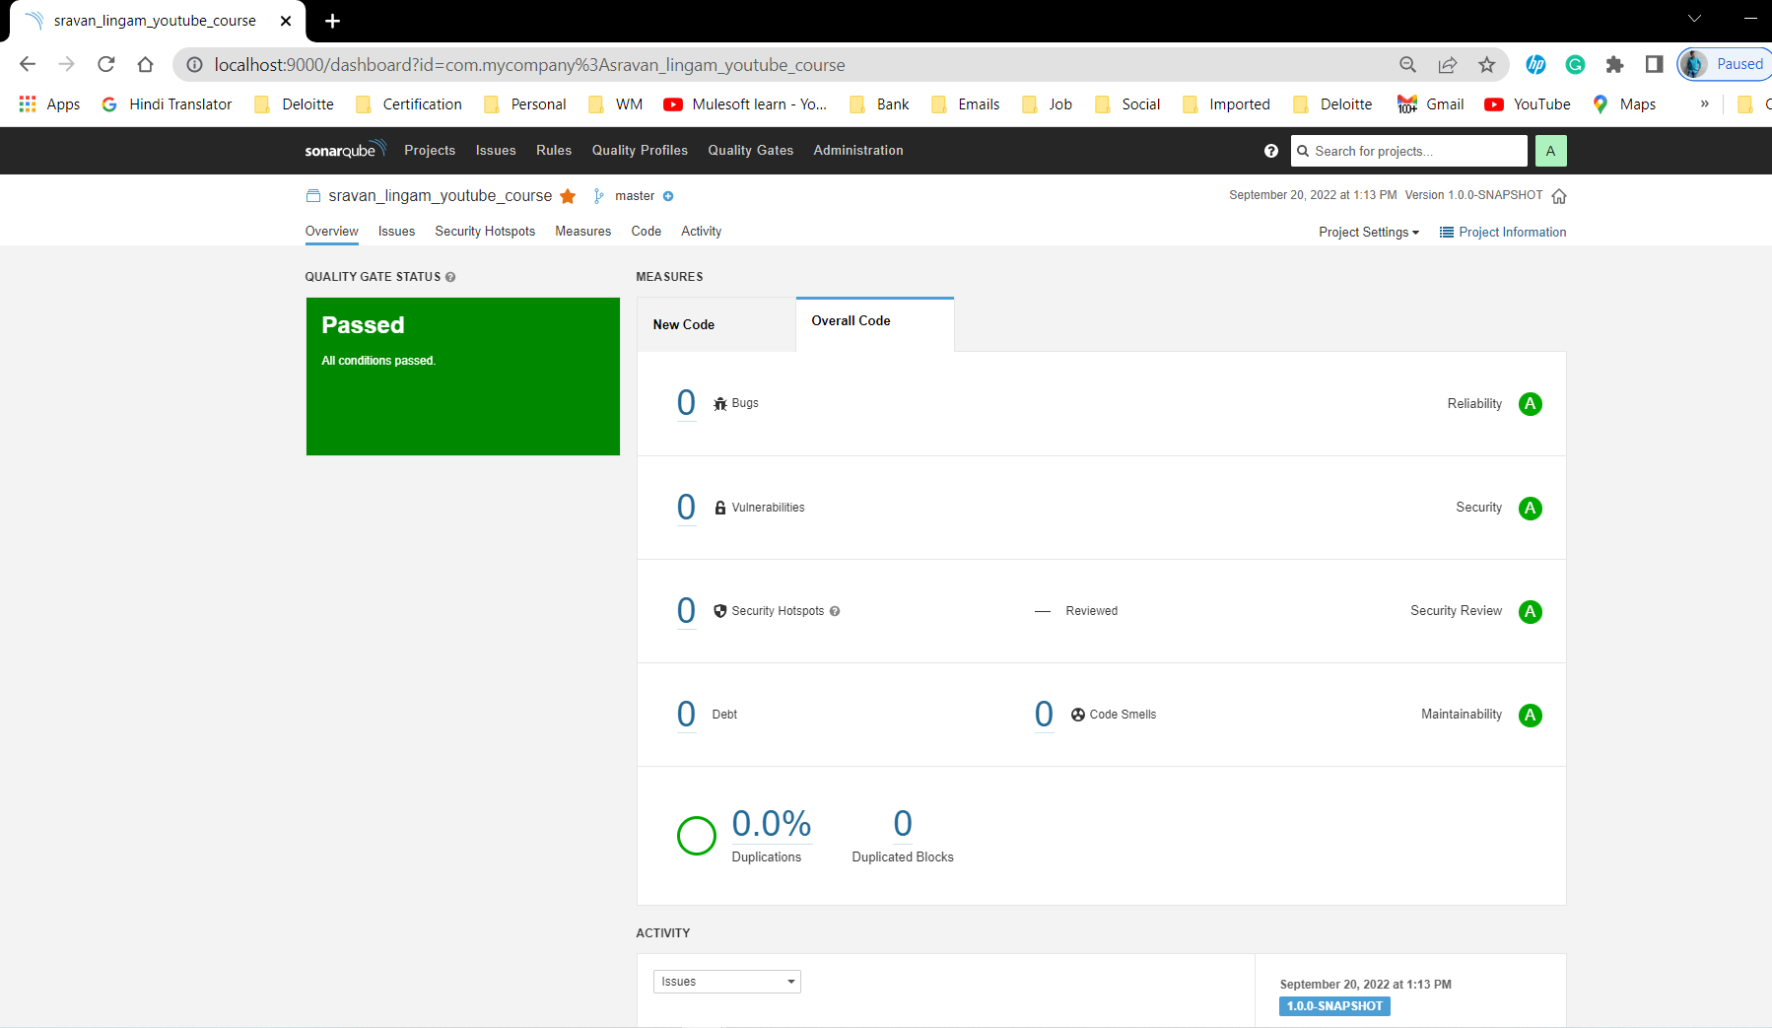

## 🧹 CleanUp

Stop sonarqube services and delete the instance

Stop Jenkins service and delete the instance